

JCMS Access Interface Release Notes

**Release No 6.1.9**

May 2015

# Documentation

This version’s code will be placed onto GitHub for public use. All modules have had the following comments added:

***

Copyright (c) 2015 The Jackson Laboratory

This is free software: you can redistribute it and/or modify it

under the terms of the GNU General Public License as published by

the Free Software Foundation, either version 3 of the License, or

(at your option) any later version.

This software is distributed in the hope that it will be useful,

but WITHOUT ANY WARRANTY; without even the implied warranty of

MERCHANTABILITY or FITNESS FOR A PARTICULAR PURPOSE. See the GNU

General Public License for more details.

You should have received a copy of the GNU General Public License

along with this software. If not, see <<http://www.gnu.org/licenses/>>.

***

# Defect Fixes

The print blank cage card form has been modified to display any error messages that might occur during the print function for mating cards. Other card formats will continue to ignore any errors.

If you are using a customized mating card and an error message is displayed about a missing field “penIDBC” you will need to modify the card’s report format to include a field with that name and set the field’s visibility property to false.

**Release No. 6.1.8**

January 2015

# Defect Fixes

The browse sample storage locations form never shows results in the “Sample for Selected Node” box. It always stays gray as shown below. Note that if the form is working correctly, the lower box background will change to white even if there are no samples stored at the selected location.

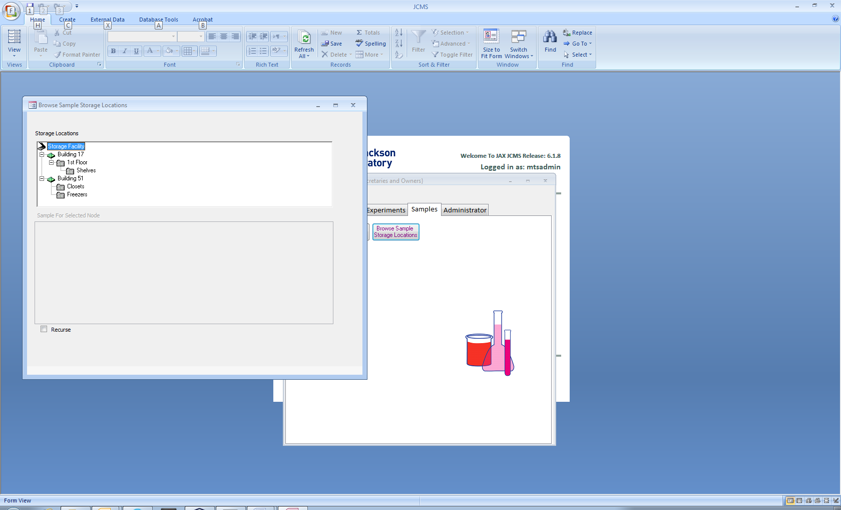

Origin of the problem: In 2012 Microsoft released an Office update that caused the tree view shown above to malfunction. The tree is visible, but clicking on a node to display the samples found in that location does not work. The tree view is a “control” found in a file called mscomctl.ocx. This file will need to be unregistered and then re-registered on an affected computer.

The problem is tied to specific computers, not all computers will have the problem.

If you are using Office 2007 service pack 3 (SP3) you will find the fix on the web page below. I suggest using the "fix" link.

[support.microsoft.com/kb/2687441](http://support.microsoft.com/kb/2687441)

If you are using Office 2010 the fix is here:

[support.microsoft.com/kb/2687503](http://support.microsoft.com/KB/2687503)

If you are using a different version of Office, carefully follow the instructions on one of the above pages to manually delete the registry entry and re-register the mscomctl.ocx file.

After running the fix, if the browse sample storage locator form is still not working and instead gives some error messages, you will need to upgrade to the JCMS Access interface version 6.1.8.

**Release No. 6.1.7**

December 2014

# Defect Fixes

Import genotype will now work properly for users who have a large number of mice (> 32,767). Previously it was giving an “overflow” error.

**Release No. 6.1.6**

December 2014

# Defect Fixes

A change has been made to the Access Interface Upgrader/Installer to solve a problem causing it to stop when attempting to “drop foreign key”.

No change has been made to the interface software; therefore this release is only needed if you encounter the upgrade error.

**Release No. 6.1.5**

November 2014

# Functional Improvements

Users may now set their Windows date format to be different from the standard United States mm/dd/yyyy (month/day/year). Previously, using a date format such as dd/mm/yyyy might have resulted in reversing the month and day in the data. For example, 5/11/14 (November 5th in the dd/mm/yyyy format) was saved as May 11th.

Change the Windows date format by going into Control Panel, select “Clock, Language, and Region”, and then “Change the date, time, or number format”. Next select the “Short Date” format. Please note this is a system-wide change affecting all of this user’s software on a specific computer running a Windows operating system.

# Defect Fixes

A defect was causing the Edit Mating and Retire Mating forms to not display the dam(s) and sire associated with certain matings. All dams and sires are now displaying properly.

**Release No. 6.1.4**

August 2014

# Defect Fixes

A defect was causing a null error message from the Import Experimental Data feature. It only occurred when the Test Type used for the import had previously been edited.

**Release No. 6.1.3**

May 2014

# Defect Fixes

A defect was preventing a brand new user of JCMS from adding new owners. This affected only users that downloaded the JCMS Access interface without the JCMSWeb interface.

**Release No. 6.1.2**

March 2014

# Functional Improvements

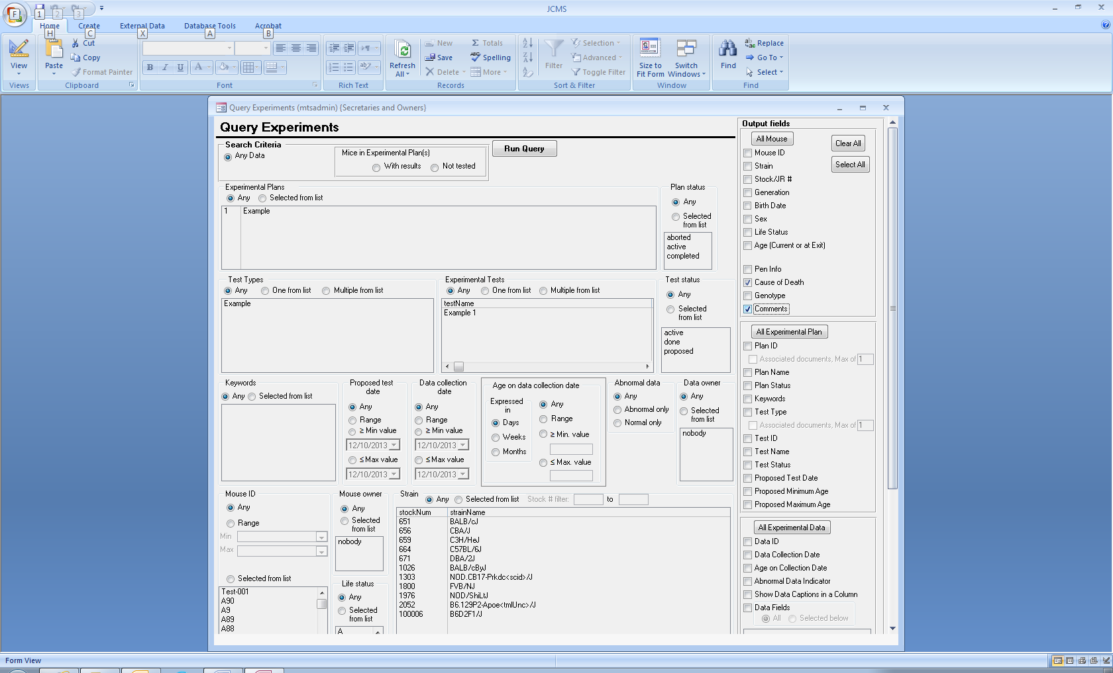Below is a description of the new functionality that went into this release. For a complete description please see the user guide.

## New Features

### Experiment Query

Two new output fields have been added to the Experiment query: Mouse cause of death and Mouse comments.

## Usability Changes

### Mouse, Mating, and Experiment Queries

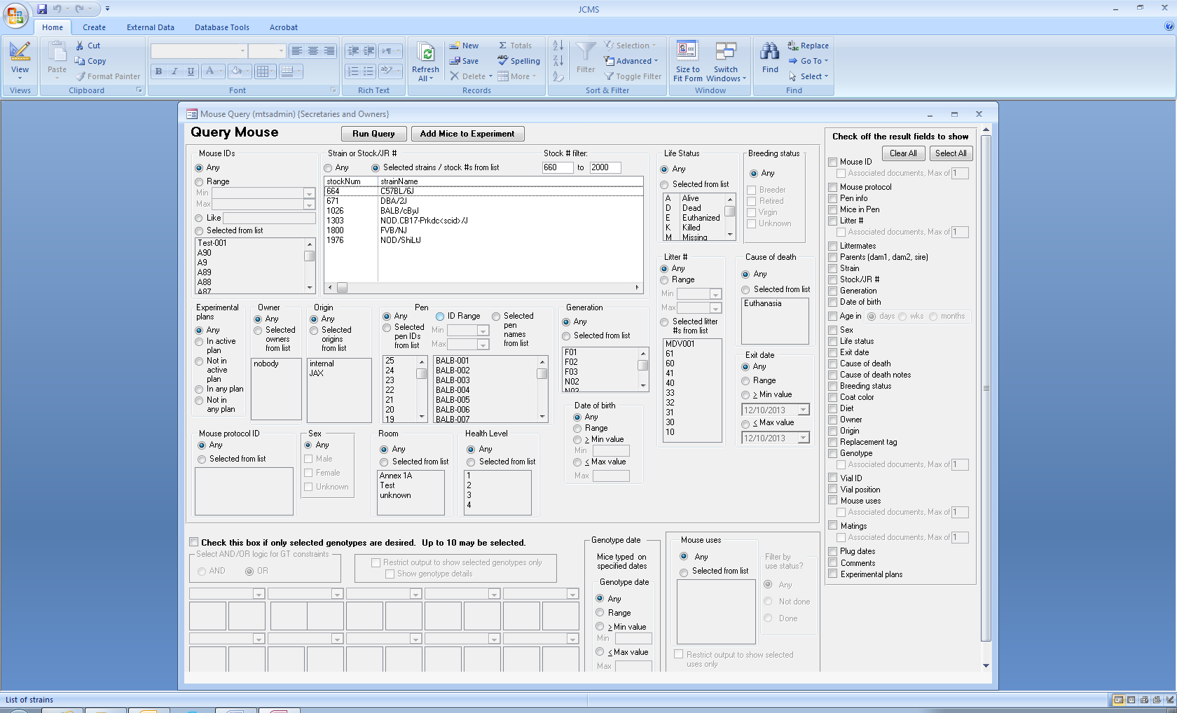A new filter is available for the strain name/ stock # choices. When the setup variable JCMS_STRAINNAME_FIRST is set to false, a stock # filter will replace the strain name filter. A range of numbers may be entered. If only one number is entered, the list will be displayed starting with it as the minimum stock # or ending with it as the maximum stock number. The strains are displayed in stock number order.

### Experiment Work Report

The query used by this report has been replaced by one that is more efficient, reducing the wait time.

# Defect Fixes

## Wean Work Report

Occasionally, some fields were displayed with hash marks (#####). These fields are now wider and are able to wrap to a second line if the text does not fit.

## Cage Use Report

When the cage use report was left open on the screen and new criteria were entered, the report was displaying the previous criteria in the top section. Now the report will close and reopen with the correct criteria displayed.

## Experiment Query

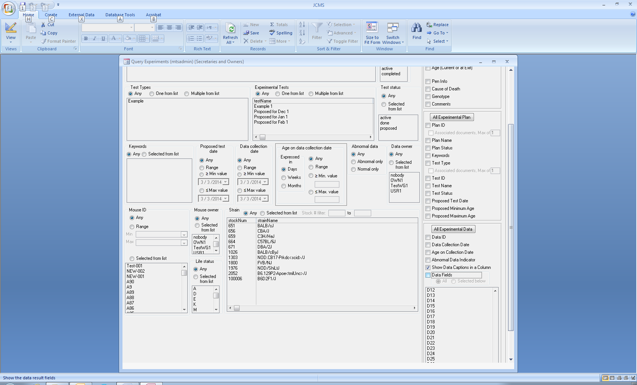An error message displayed when “Show Data Captions in a Column” is checked, but “Data Fields” is not checked has been removed.

**Release No. 6.1.1**

November 2013

# Usability changes

### Add Litter

The setup variable MTS_AUTO_LITTER_NUMS, by default, is set to “On” indicating to JCMS to provide a sequence of automatic litter numbers associated with a mating. When a new mating ID is selected, JCMS clears the litter # shown on the form. This helps to prevent accidentally using a number for a different mating’s sequence. The “Next Litter Num” button is provided in order to quickly obtain the next number in the sequence for the mating.

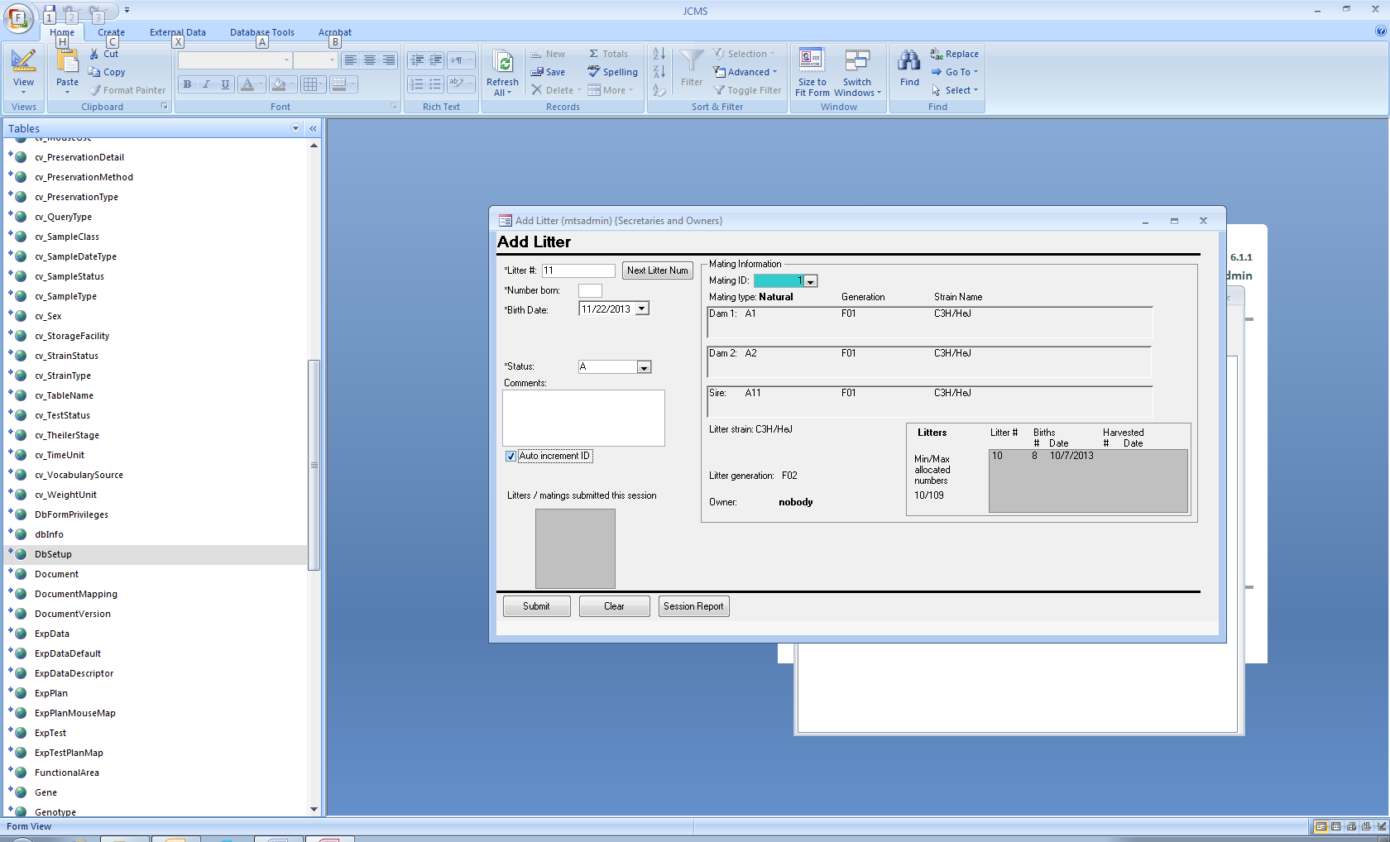

The MTS_AUTO_LITTER_NUMS setup variable is changed to “Off” to indicate the user prefers their own litter number sequence. Now the litter # will not be cleared and the user may check “Auto increment ID” to obtain a continuous sequence of litter numbers, such as ABC0009, ABC0010, ABC0011.

### Add Mating and Edit Mating

An annoying pop-up error message about missing terms for technical matings has been replaced with a warning message on the form.

### Retire Mating

A pop-up error message about a “Null error” has been removed.

**Release No. 6.1.0**

October 2013

# Functional improvements

Below is a description of the new functionality that went into this release. For a complete description please see the user guide.

## Usability changes

### Experiment Work Report

The Owner and Test Type Experiment Work Reports have been combined into one report called the Experiment Work Report. It offers two types of output, either a formatted report for printing or a datasheet for exporting into Microsoft Excel or other spreadsheet program.

The criteria for selecting the mice to show in the results include:

* Time frame
* The proposed test date is in the time frame or the mouse’s age is within the proposed minimum and maximum age range
* All mice in a test or only untested mice
* Mouse life status
* Experimental plan owner
* Experimental test status
* Test types
* Experimental tests

Selections that are made on the form for owner, test status, and test type are used to limit the experimental test choices.

Several new fields have been added to the output, including proposed minimum age, proposed maximum age, age today, age on proposed date, date age window begins, date age window ends, today’s date, test type, and data collected (Y/N).

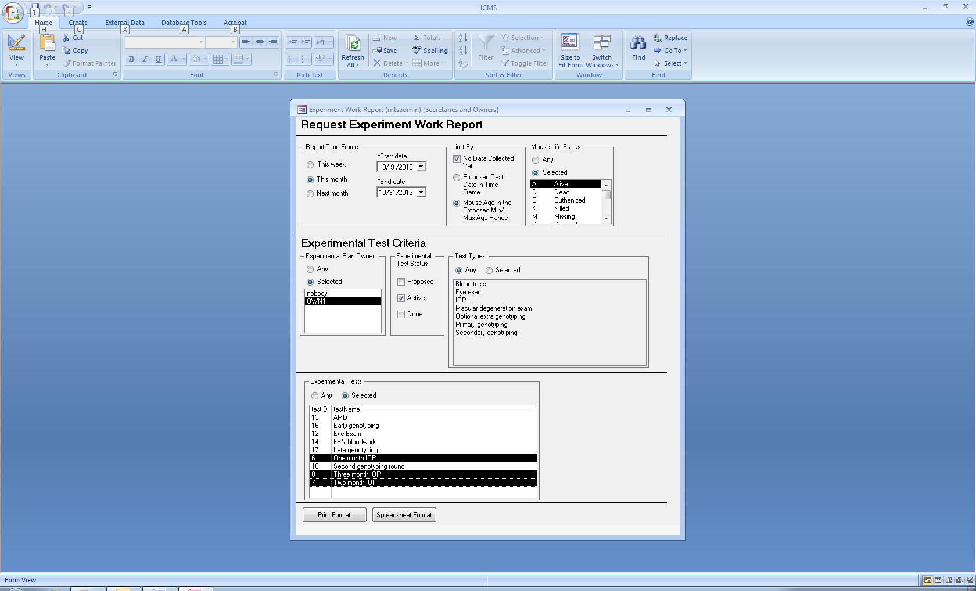

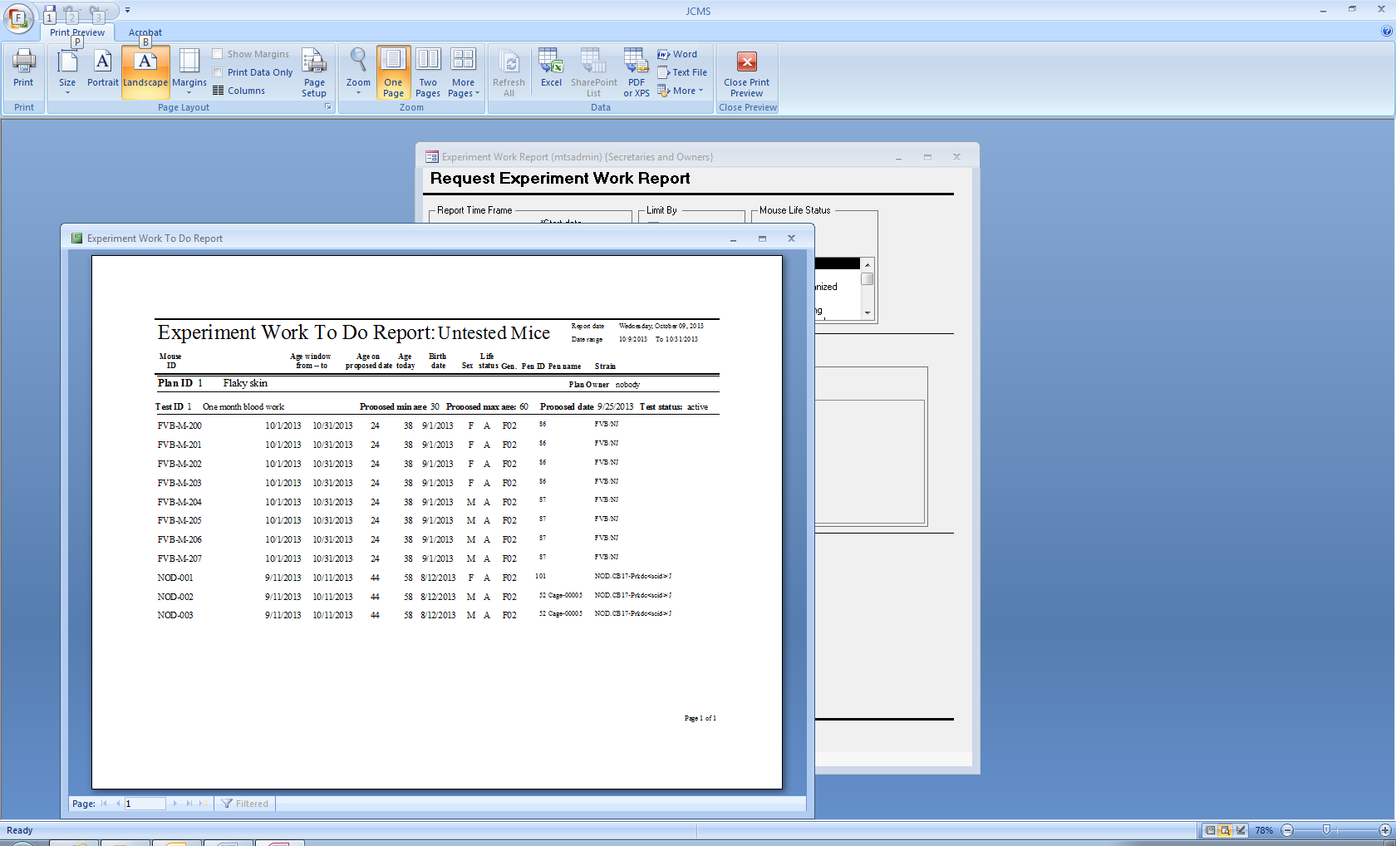

Sample report output

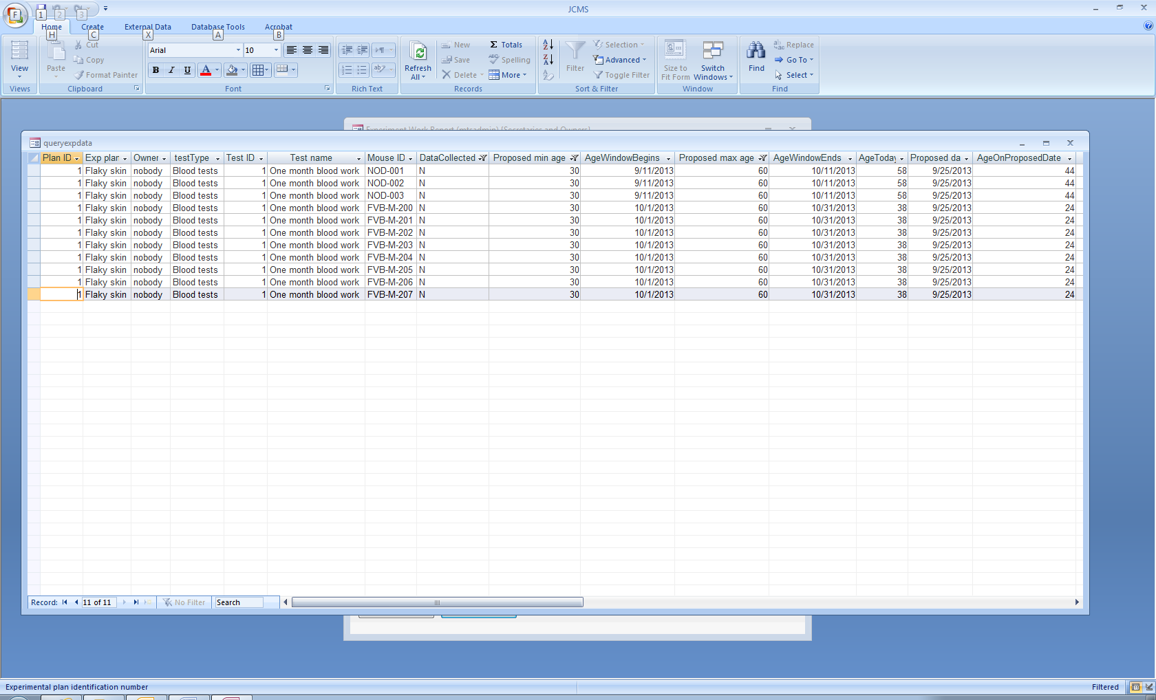

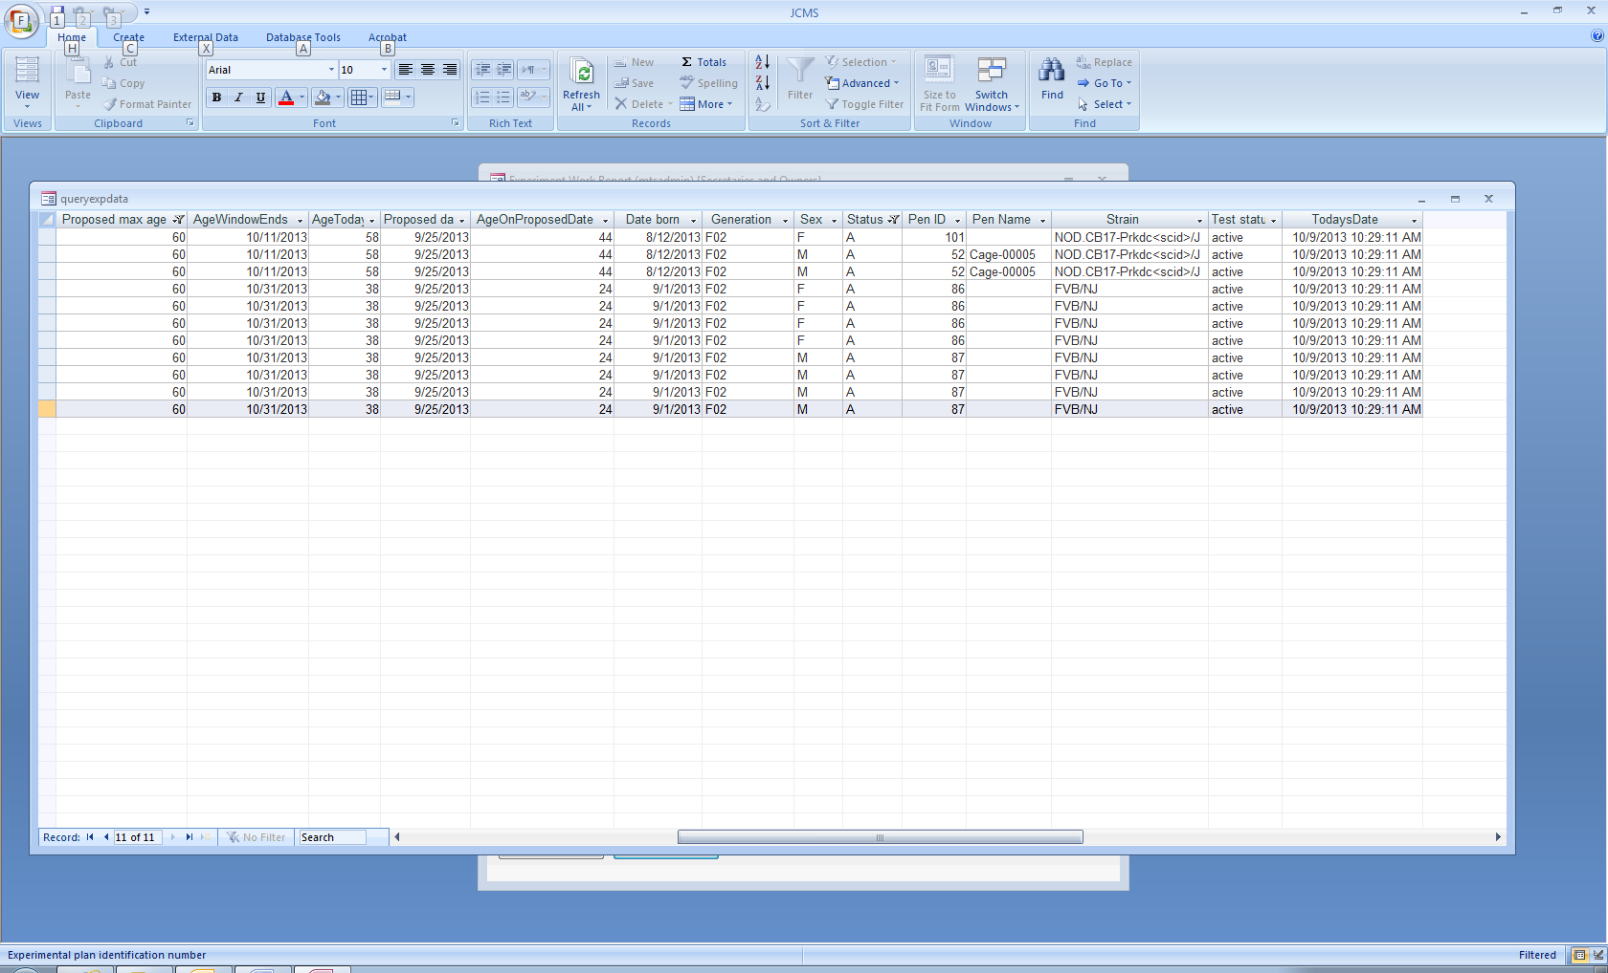

Sample spreadsheet output

### Edit Experimental Test form

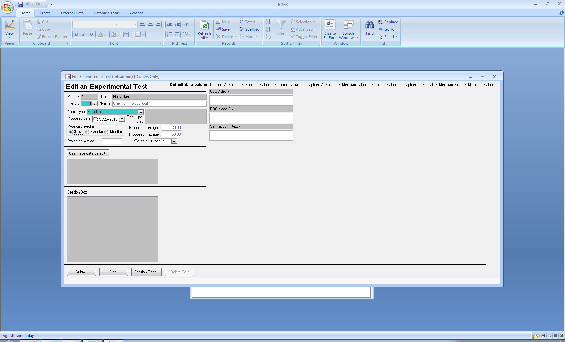

Changing the selection of age from days to weeks or months will immediately show the changed value.

### Associated Documents Warning Message

On the query forms, the pop-up warning message displayed when the document feature is not in use has been replaced by a warning message shown on the form. This message is displayed if any of the “Associated documents” check boxes are selected, and then the check mark will be removed from the check box.

To never see this message, even if not using the documents feature, simply set JCMS_DATA_FILE_DIRECTORY to a value, such as C:\Users\abc\Documents. However in this case, if “Associated documents” is accidentally checked, extra blank columns for documents will be added to the output.

### 

**Release No. 6.0.0**

September 2013

# Functional improvements

Below is a description of the new functionality that went into this release. For a complete description please see the user guide.

## New features

### Technical Matings

Three new mating types have been added.

* Embryo Transfer (ET) involving an embryo sample and host dam
* Ovary Transfer (OT) involving an ovary or ovarian tissue sample, host dam, and sire
* In vitro Fertilization (IVF) involving an egg sample and sperm sample

All matings except IVF may have a natural (live birth) litter. All matings may have an embryo litter. An embryo litter consists of harvested embryos or embryonic stem cell samples. To obtain a live birth from an IVF mating, create embryo sample(s) that are then used in an embryo transfer mating.

### Filters on Mating Forms

The mouse and sample choices may be filtered to show only one strain by selecting (or removing) the strain in the Strain/Stock # criteria section at the top of the form. The mouse choices may be filtered to show only live mice by checking the “Select only live mice” checkbox.

### Approved Mating Strain Change

The setup variable JCMS_ENFORCE_APPROVED_MATINGS is used to set the “Approved only” radio button on or off when the mating form is opened. The user then may change the setting between all, active, and approved strains as desired. The approved choice is disabled if no mating strain choices have been created by the administrator using the Add Approved Mating Strains form on the Administrator button bar.

### Auto Increment Generation Change

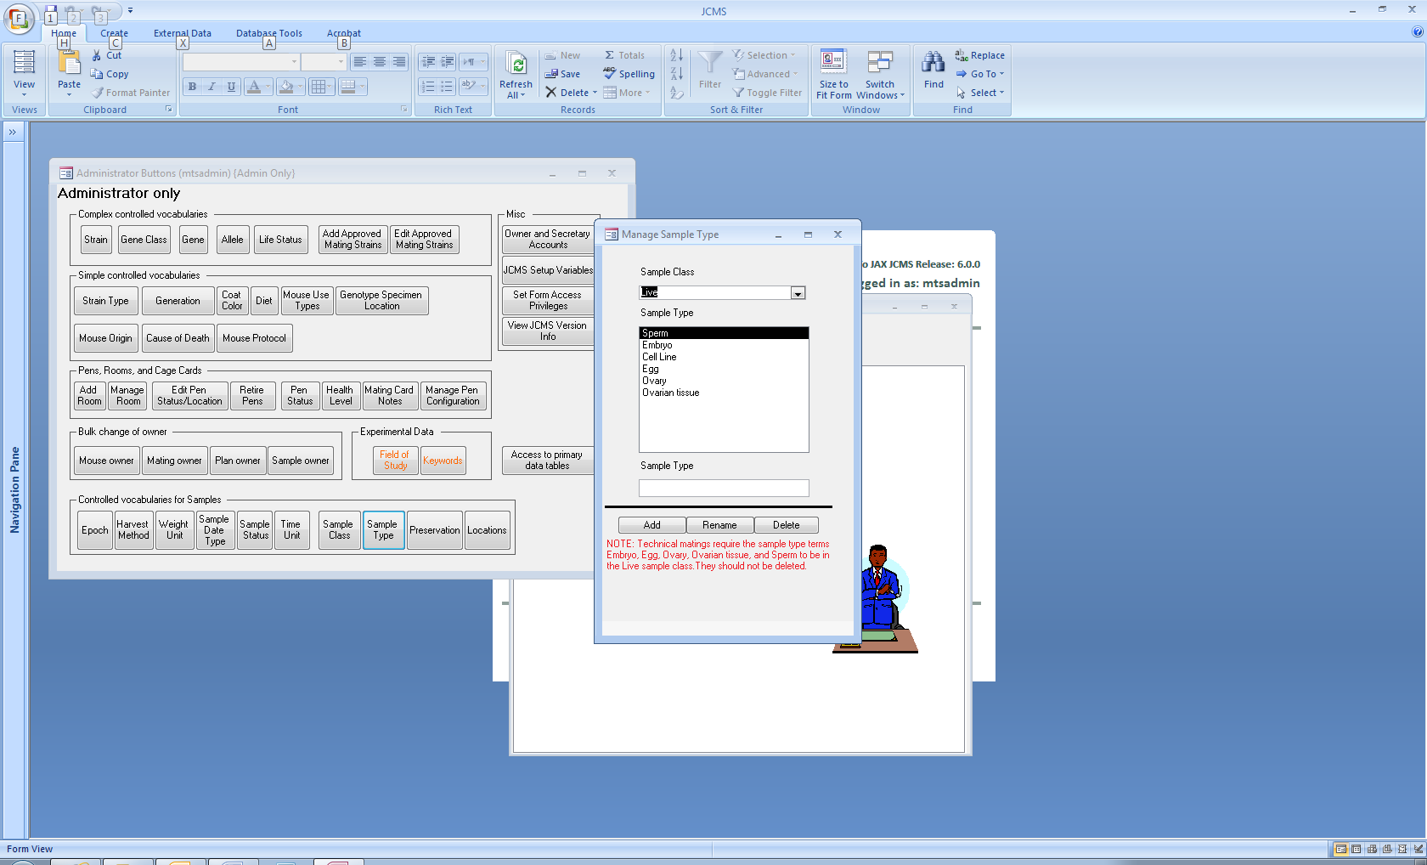The litter generation will be automatically set on the mating forms any time the auto increment generation check box is checked and there are mice selected for the components of the mating.

### Required Sample Class and SampleTypes

In order to use technical matings, several terms are required for the sample class “Live”. These include egg, embryo, ovary, ovarian tissue, and sperm. These terms are created by the JCMS upgrader/installer and should not be deleted.

### Hint for Tab Key Users

In order to tab out of the dam1, dam2, sire, host dam, and sample combo boxes, hold down both the Control key and Tab key simultaneously.

**Release No. 5.1.0**

July 2013

# Functional improvements

Below is a description of the new functionality that went into this release. For a complete description please see the user guide.

## New features

### Sample Genotypes

Genotypes may now be associated with either a mouse or sample.

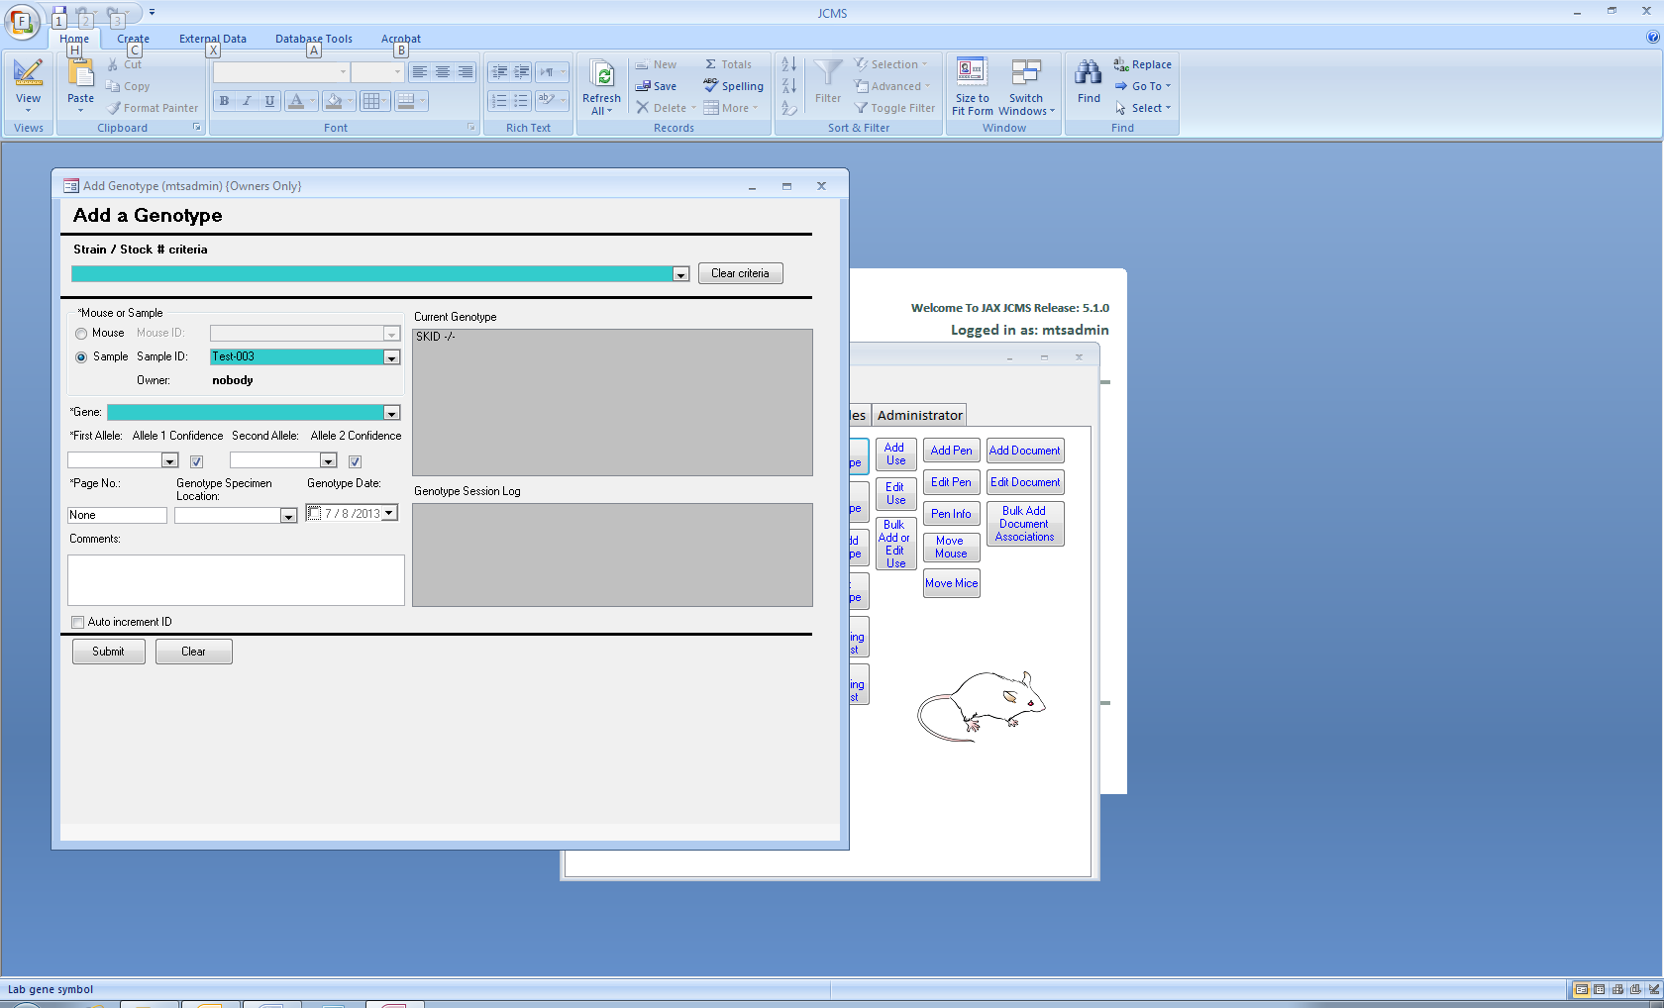

“Set Genotype” buttons used to open the Add Genotype form have been added to the Add Sample, Edit Sample, and Add Embryo Litter forms.

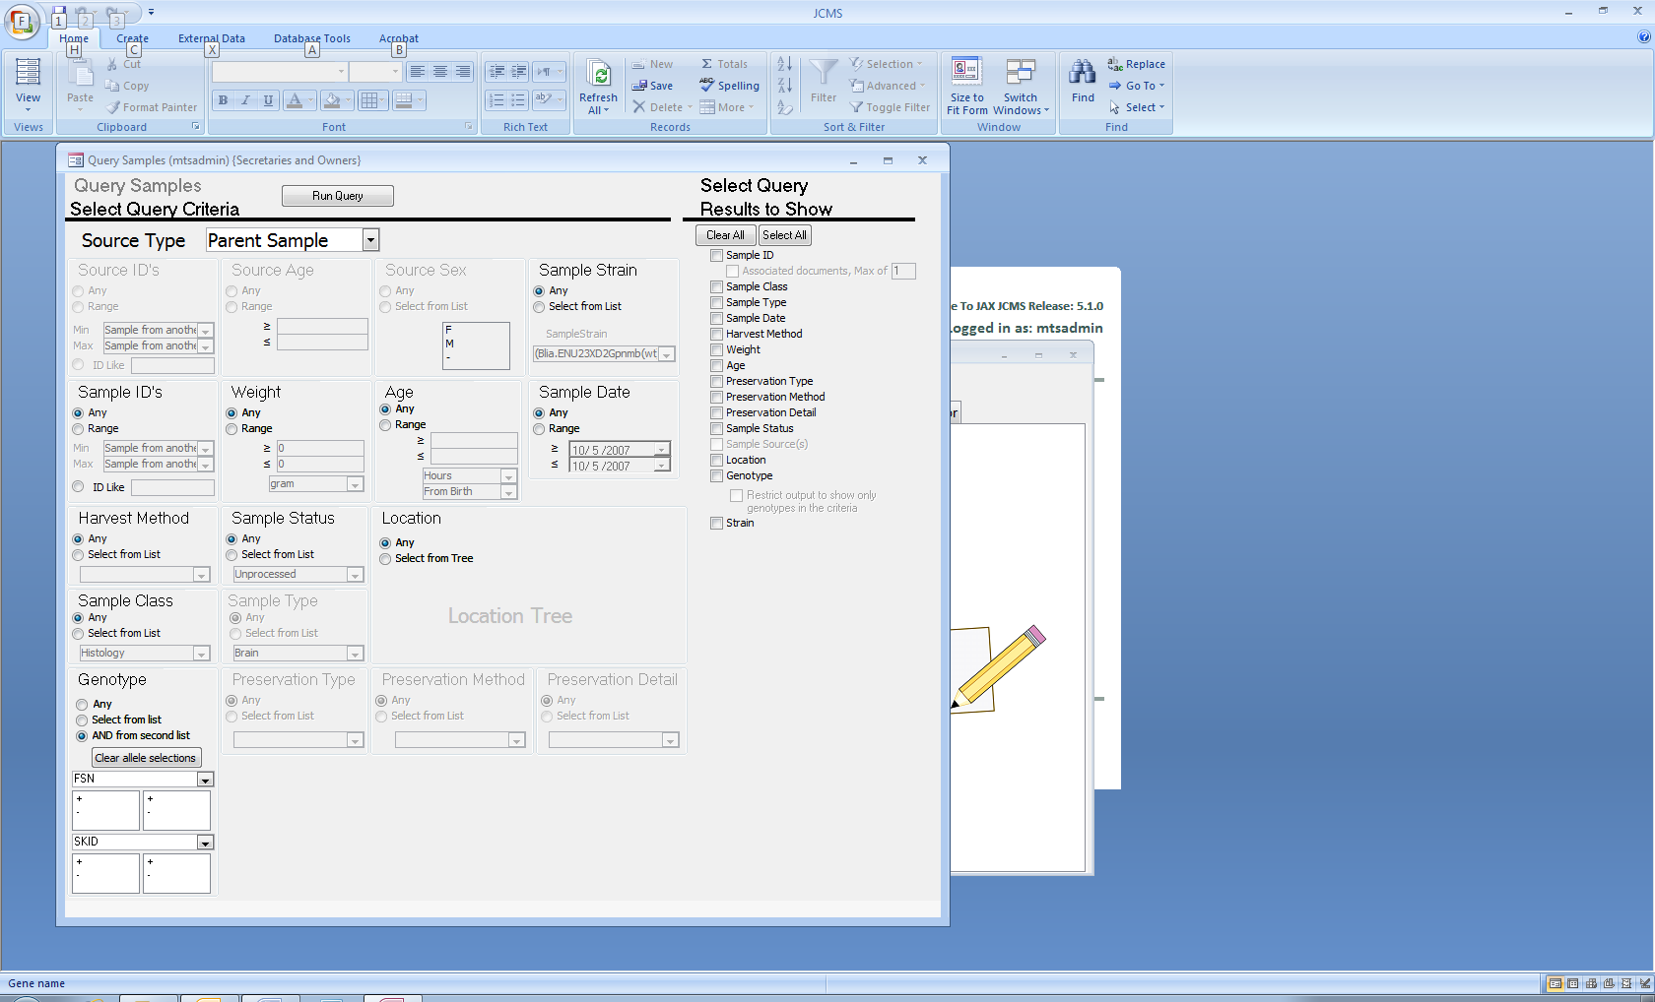The Sample query form can now return the genotype(s) associated with individual samples. Up to two genotypes may be used as criterion for the query. Combinations of specific alleles may also be specified.

## Usability changes

### Strain filter for the Add and Edit Genotype forms

The strain or stock # may be used to filter the list of mouse ID or sample ID choices on the add and edit genotype forms.

### Strain results for sample query

The sample query form now includes the sample’s strain in the result choices.

### Edit genotype form

The edit genotype form will now clear after an update has been submitted. The update and delete buttons are disabled until an existing genotype has been selected by double clicking on it.

**Release No. 5.0.0**

June 2013

# Functional improvements

Below is a description of the new functionality that went into this release. For a complete description please see the user guide.

## New features

### MySQL required for data storage

Starting with JCMS 5.0.0, the data tables will use MySQL and the Microsoft Access data tables (JCMS_db.mdb) will be discontinued. Microsoft Access is still required for the user interface.

The first step in upgrading to JCMS 5.0.0 is to convert to using MySQL if you have not already done that. The instructions for converting to MySQL are located on the JCMS website: <http://colonymanagement.jax.org/jcms_db_conversion_tool.html>

Once your data tables have been successfully converted, look on the JCMS website (<http://colonymanagement.jax.org>) for the new JCMS Install and Upgrade tool. Note the same tool is used for a new installation or upgrading an existing installation. For the detailed instructions, see the document JCMSInstall-Upgrade-guide.pdf, which is included with the tool.

### Embryo Litters

An **embryo litter** is created by harvesting embryos or embryonic stem cells from a dam in a mating. The harvested material can optionally be recorded and tracked as a Sample. The new Add Embryo Litter w/Samples form is modeled after the Add Litter w/Pups form and includes many of the fields found on the Add Samples form. The following new fields are added to the litter record: number harvested, harvest date, days post conception (DPC), and litter type.

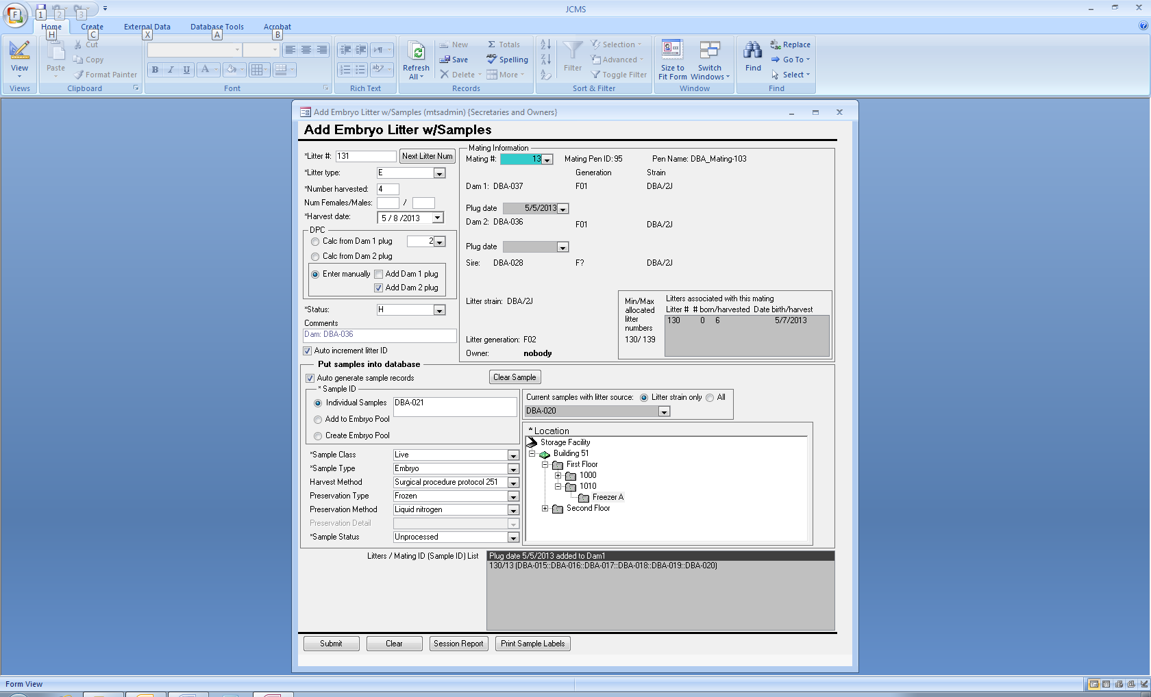

### Days Post Conception

The days post conception (DPC) is required for an embryo litter and, if samples are created, this number is saved as the age in days from conception in the sample record. A table showing the relationship between the DPC and Theiler Stage is provided to aid in determination of the proper number. This table is derived from e-Mouse Atlas (EMA).

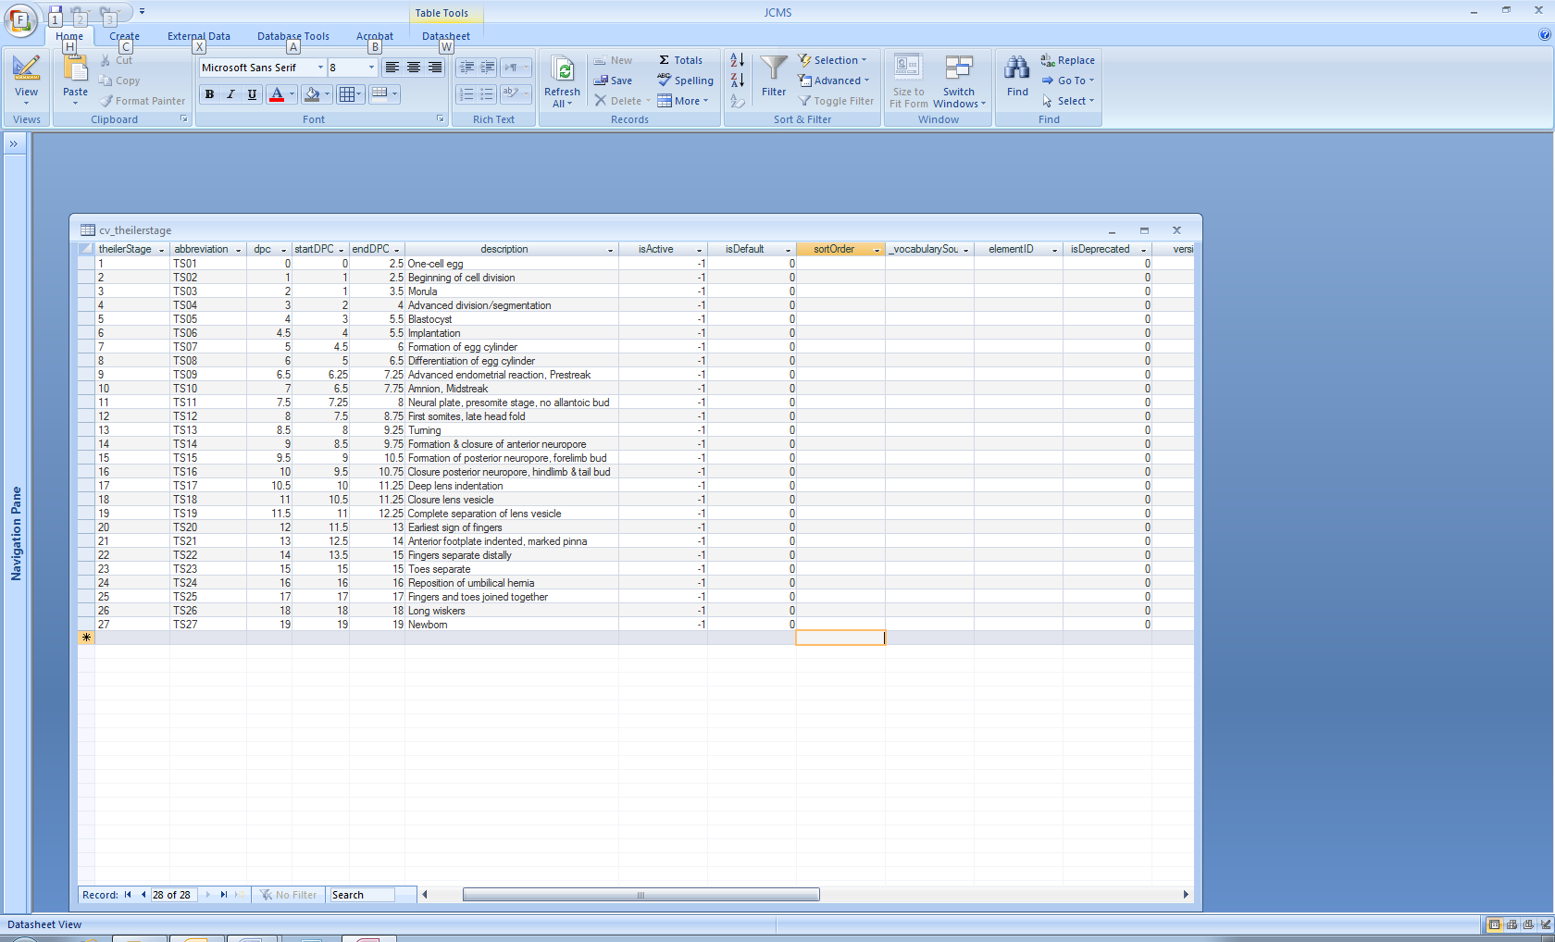

The dpc may be entered by choosing it from the table or calculated from the harvest date and dam’s plug date by selecting one of the radio buttons shown below. If the dam does not have a plug date for this litter, it will be automatically entered by JCMS if “Add Dam 1 (or 2) plug” is checked.



You may create individual samples or put them into an embryo pool, which is recorded as a single sample.



The “Current samples” combo box is provided as an aid to determine the new Sample ID or for choosing an existing Sample ID.

### Edit Embryo Litters

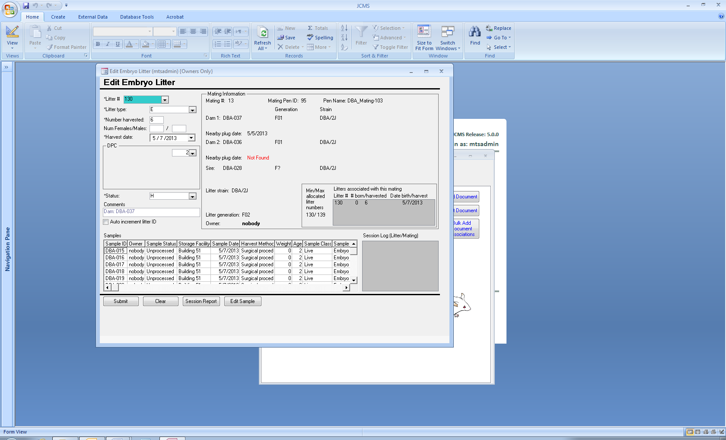This new form may be used to correct an error in the litter information. A sample ID may be selected for editing from the grid at the bottom of the form. Then click the “Edit Sample” button to open the Edit Samples form.

## Usability changes

### Mating Query

The Mating Query has the new litter fields added to its results choices.

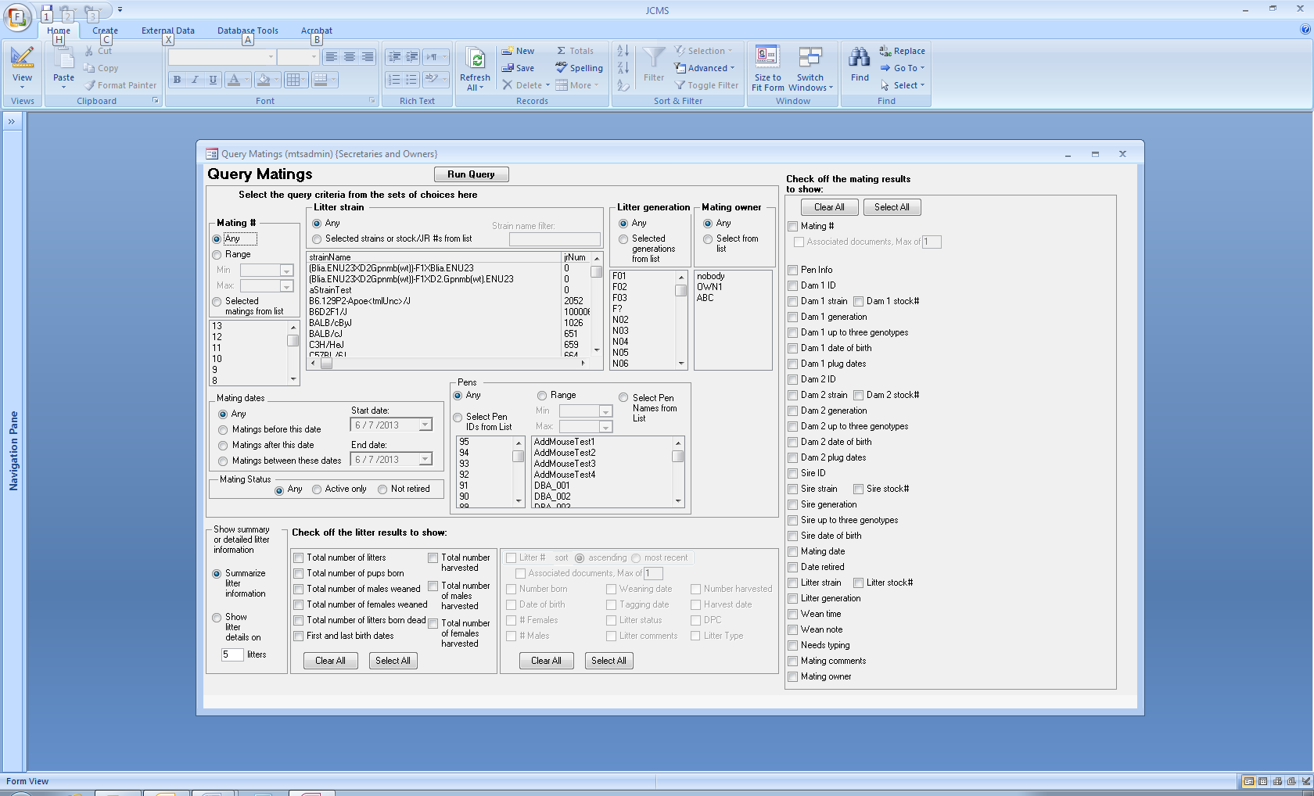

The new “Litter Type” field uses the term “Live Birth” for all regular litters and either “Harvested Embryos” or “Embryonic Stem Cells” for embryo litters.

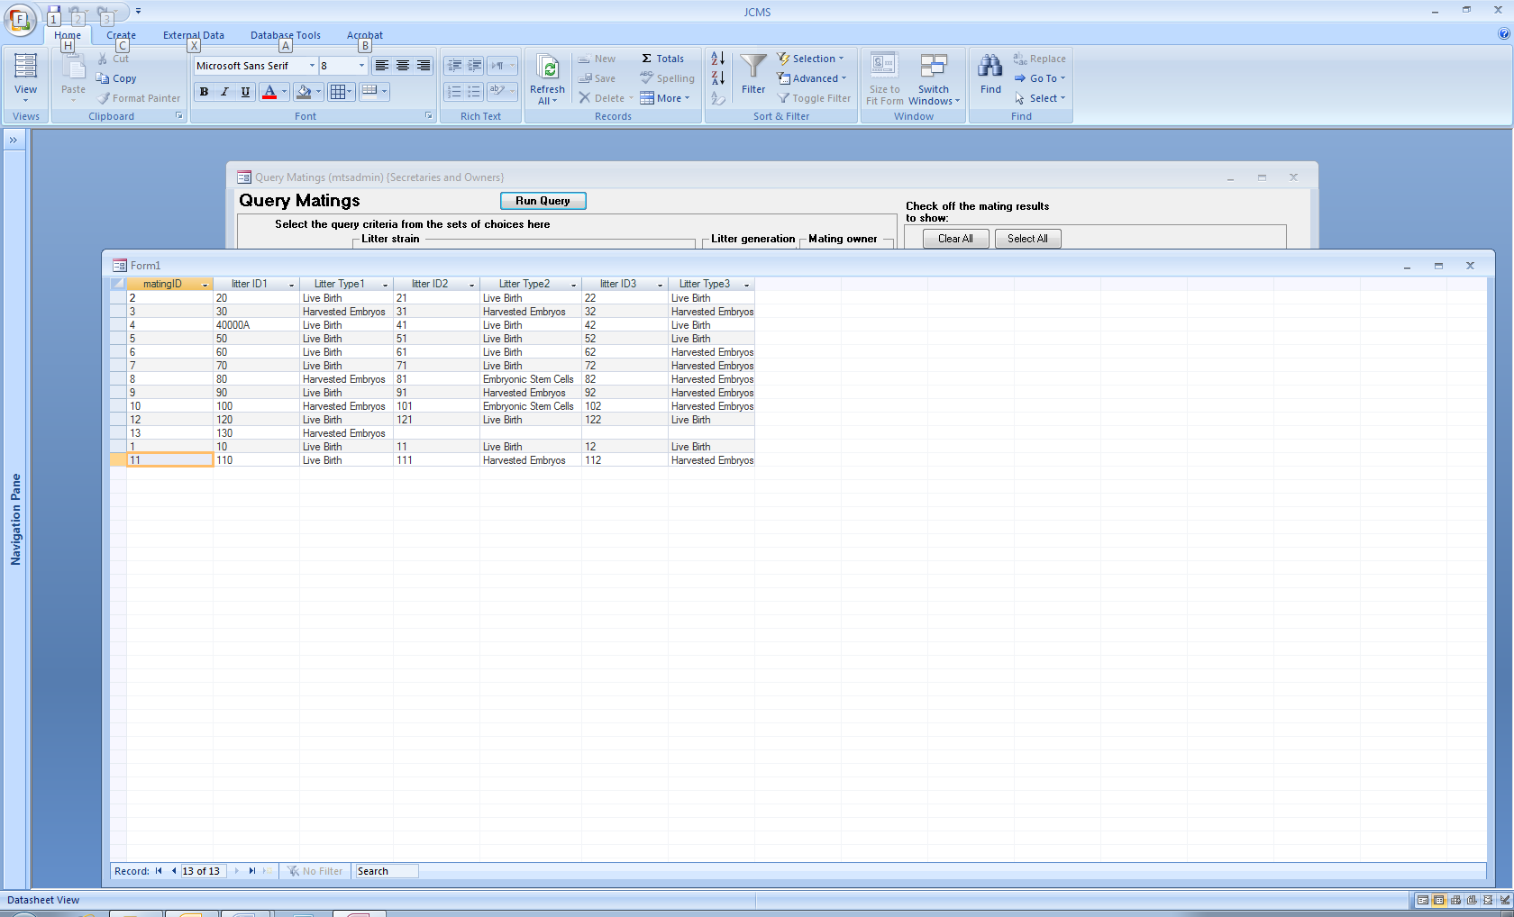

When summarizing the litters, the mating query counts litters based on the litter status field. Set the status to “H” for embryo litters and “D” to be counted as a litter born dead. An embryo litter may have the # M and # F entered if it is desired to record this information. The total # of M/F weaned is counted for litters with a status of “A” and total # M/F harvested for litters with a status of “H”.

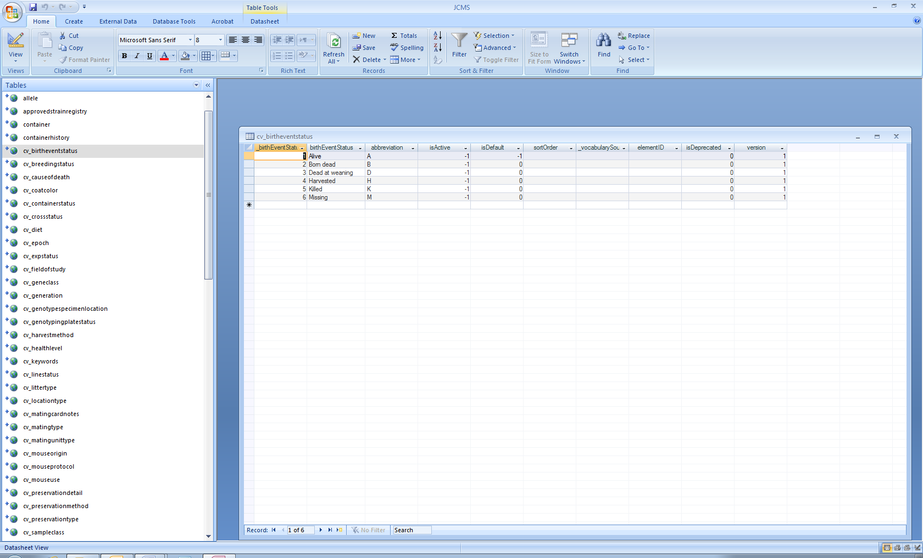

## Defect fixes

### Add Mouse and Add Pup from Litter forms

* The overloaded cage warning was not always displayed.
* The overloaded cage warning now checks the cage to see if the current contents of live mice is **≥** MTS_MAX_MICE_PER_PEN instead of **>** MTS_MAX_MICE_PER_PEN, which was allowing one extra mouse to be placed into the cage.

### Edit Samples

* Litters now display correctly that the age is stored “from birth” or “from conception”.
* The “calculate age” button is disabled unless the age is “from birth”.

### Bulk Add Samples

* Preservation type, method, and details are always displayed. Previously, if one was blank, none of them were displayed.

**Release No. 4.8.4**

April 2013

# Functional improvements

## JCMS_STANDARD_WEAN_TIME and JCMS_EXT_WEAN_TIME may be blank

JCMS will no longer use default values for the setup variables JCMS_STANDARD_WEAN_TIME and JCMS_EXT_WEAN_TIME on the Add Litter w/Pups and Edit Litter forms. If the setup variables are blank, then no attempt is made to calculate the length of time between the litter birth date and wean or tag dates.

This creates a more efficient workflow for entering litters that were all weaned on the same date, but that may have different birth dates. For example, some users find that they do not wean on exactly 18 days, instead perhaps weaning at 17, 18, or 19 days.

When either setup variable is blank or some invalid character, the Wean Work Report WILL use the default values of 18 and 28 days to calculate the projected wean date shown on the report.

**Release No. 4.8.3**

March 2013

## Defect fixes

### Mouse use calendar

* Under some multi-user configurations, the mouse use calendar was displaying a “File not found” message.
* When the database is large, the calendar was taking too long to open. This time has been reduced but not eliminated. An active hourglass is now visible during the wait for the calendar to display.

### Suggestions for speeding up the calendar form

Limit the criteria to only one or two owners. The more owners included, the slower the search is to find all the mouse uses. Limit the criteria to only one or two mouse uses. Allow “any” strain instead of selecting certain ones.

**Release No. 4.8.2**

March 2013

## Defect fixes

### Mating forms

* The mating forms no longer incorrectly report a strain or generation as “not in list”.

### Wean work report

* The wean work report option “for exporting to Excel” now displays T or F in the “needs typing” column instead of -1 or 0.

**Release No. 4.8.1**

March 2013

## Defect fixes

### Mouse query

* The mouse query failed when requesting mouse uses to “restrict output to show selected uses only”.

This occurred when the mouse use term contained one or more of these special characters: period “.”, left bracket “[”, right bracket “]”, exclamation point “!”, or accent grave “`”.

To avoid the problem, these characters have been replaced in the column header of the output. No changes are made to the data.

|  |  |
| --- | --- |
| **Character** | **Replacement** |
| . | _ underscore |
| [ | ( left parenthesis |
| ] | ) right parenthesis |
| ! | | vertical line |
| ` | > Greater than |

In the example below, the results shown in Form1 list “Harvest E 12.5 Viability” in the column header as “Harvest E 12_5 Viability”.

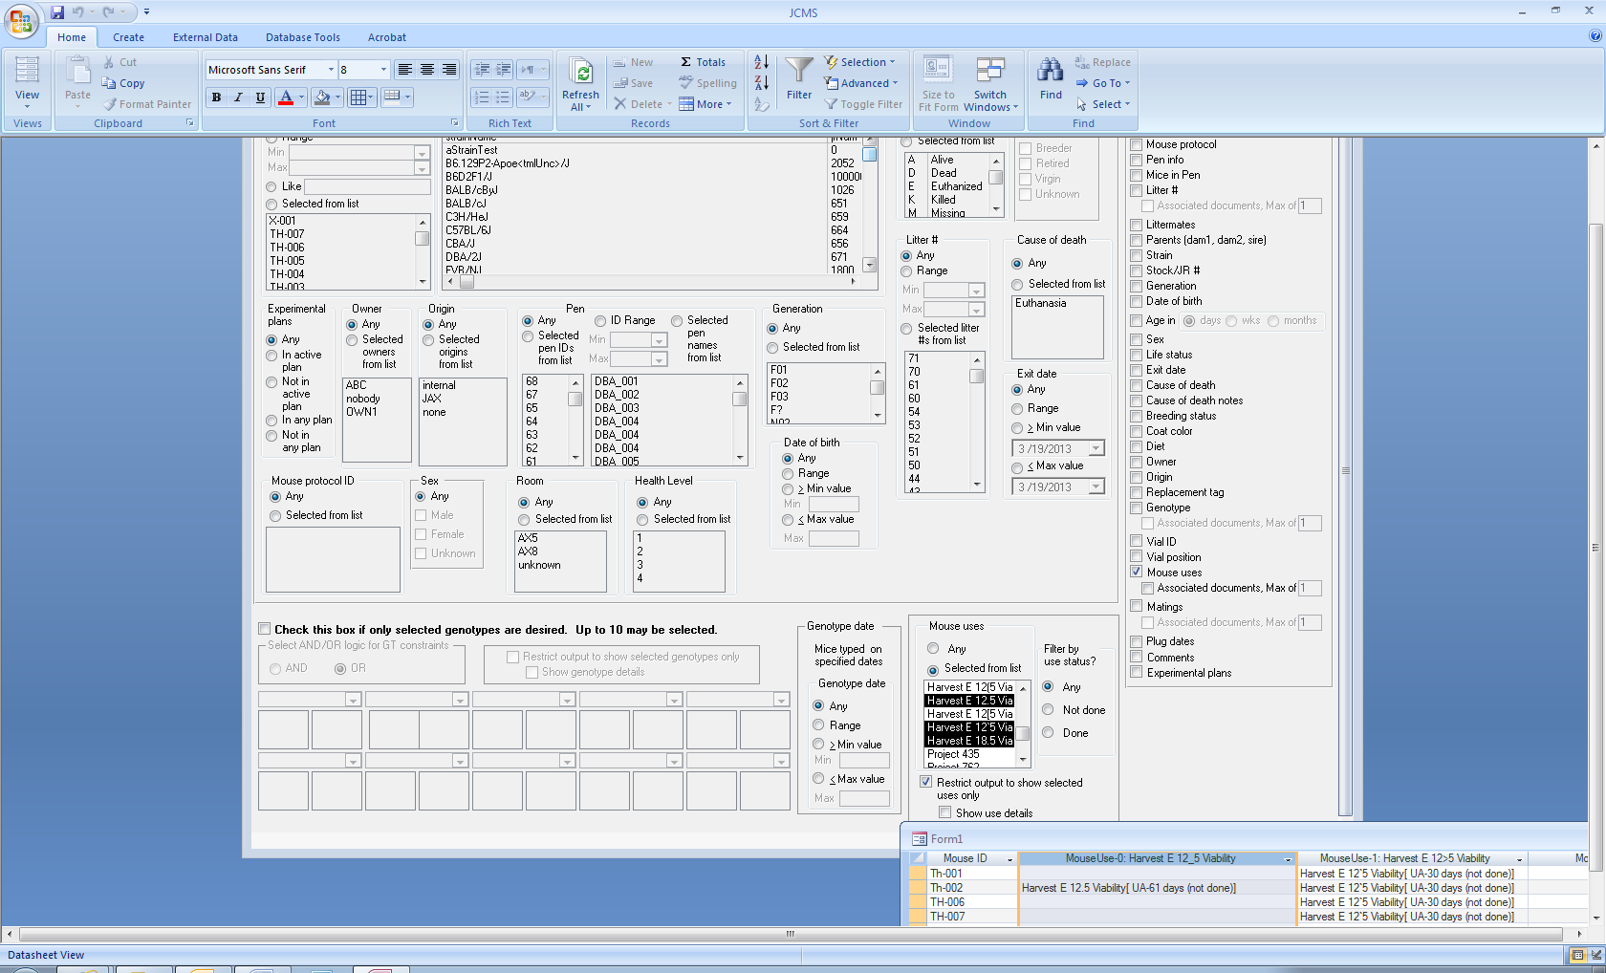

There is a rare situation where the character substitution will not work: if the replacement term happens to also be a mouse use term.

For example, suppose there are two terms “Harvest E 12[5] Viability” and “Harvest E 12(5) Viability”. It is then not possible to run the “restrict output to show selected uses only” mouse query.

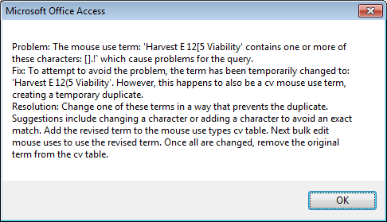

Both terms may still be used with the limitation of not being able to select them in the mouse query.

**Release No. 4.8.0**

March 2013

# Functional improvements

## Add Litter w/Pups form now allows using pen IDs in a gap in the numbering sequence

The Add Litter w/Pups form had a limitation that it always started with the next available pen ID. A starting pen ID may now be specified so long as the pen sequence created does not already exist and there are enough sequential pen IDs available to hold all the pups in the litter.

In the example below there is a gap between 68 and 74, meaning that 69, 70, 71, 72, and 73 are available. Note that empty or retired pens may not be used. The starting pen ID must be typed into the pen ID box.

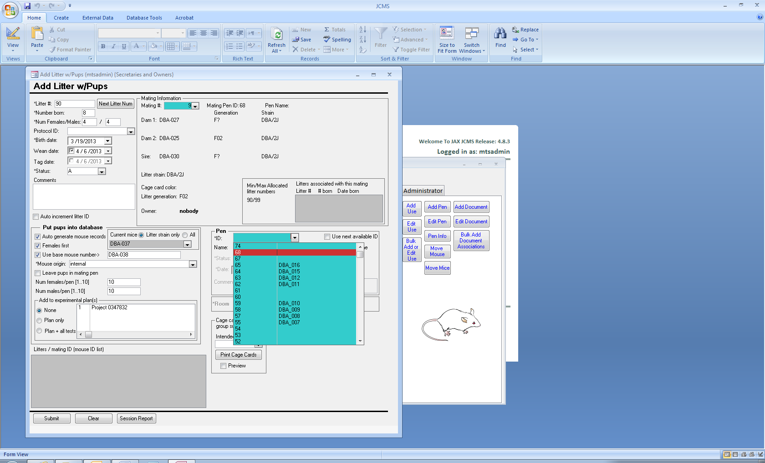

## Cage cards

It is now possible to place as many as 10 mice on a detail card, see the tutorials or our [website](http://colonymanagement.jax.org/cage_card_info.html) for directions on how to create your own cage card design.

**Release No. 4.7.0**

March 2013

## Usability changes

### Mouse-Use Work Report

The filter criteria for the mouse-use work report has been expanded to allow selecting either the projected or actual date, use status (done or not done), owner, and life status. The date may be within a range or open-ended by un-checking either the “from” or “to” date. It is possible for a specific mouse-use to have no projected or actual date. Include these mouse-uses in the report by checking “include if no date.”

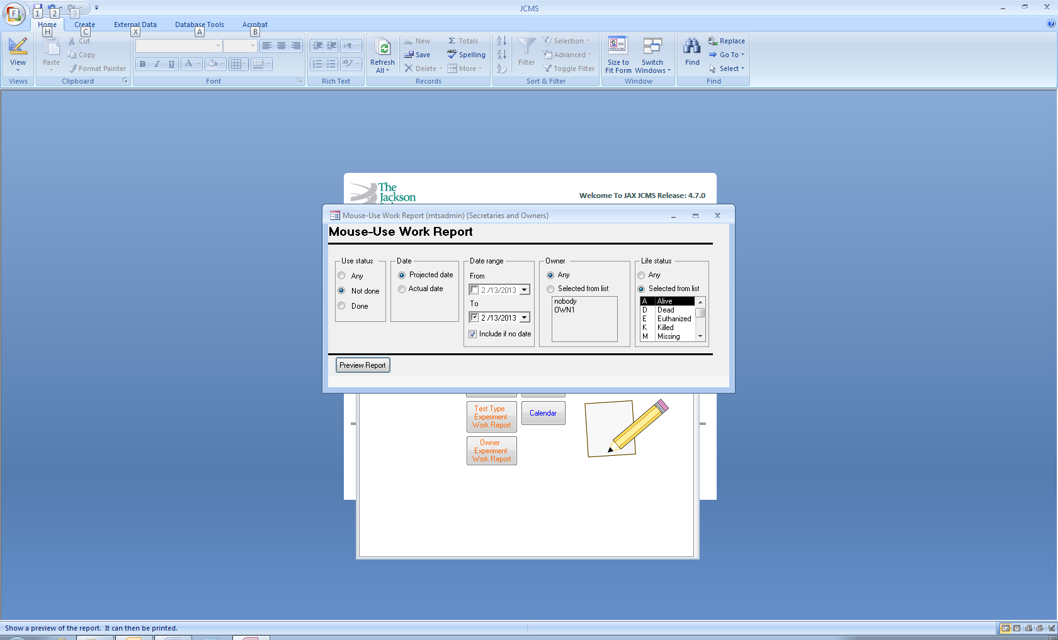

### Query Experiments

Mouse genotype information has been added to the result choices.

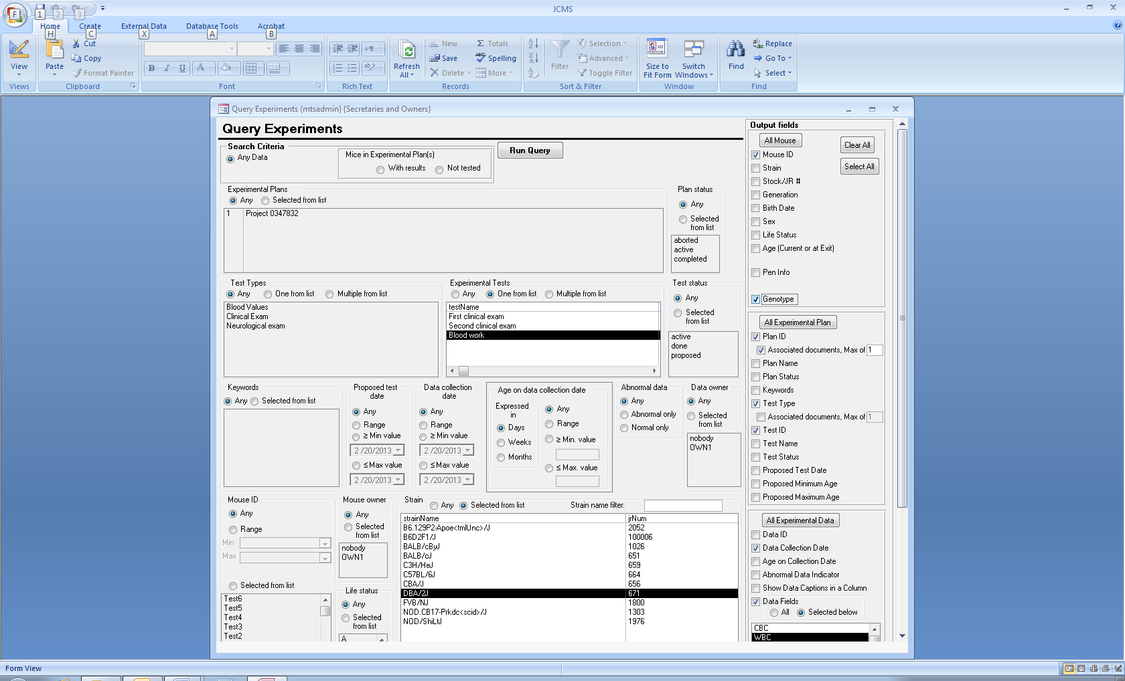

## Defect fixes

It is now possible to use F? as a generation.

#### Administrator’s Edit Approved Strain Form

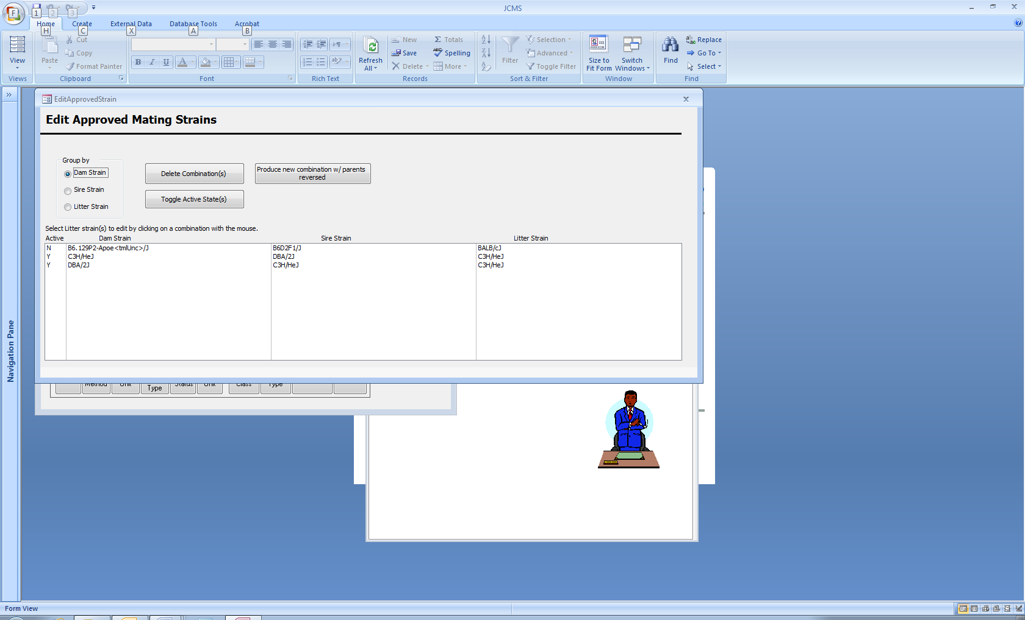

The active status is now displayed as “Y” or “N”. The Toggle Active State(s) button is working correctly.

#### Administrator’s Pen Status Form

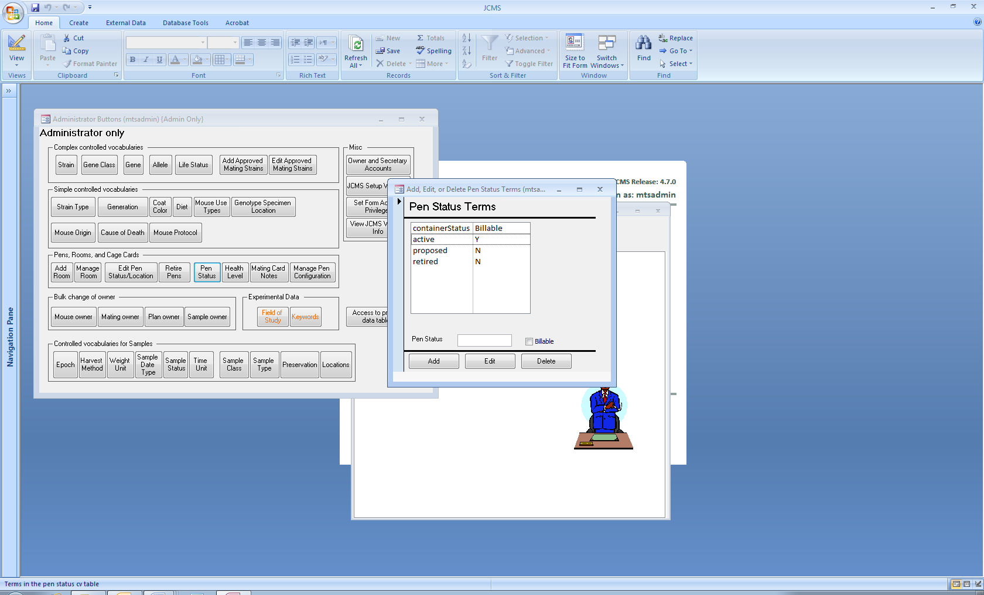The billable status is now displayed as “Y” or “N”.

**Release No. 4.6.0**

November 30, 2012

# Upgrade Completion

A change has been made to calculate and store mouse use age in days instead of months. This requires user’s existing data in the MouseUsage table to be modified (see the section “Mouse Use Age Now Calculated Using Days” below for a full description of the modification).

The first time the JCMS 4.6.0 interface is opened, the Complete Upgrade form will appear. Click the Complete Upgrade button to finish the upgrade. A Cancel button is provided to allow performing the upgrade later. However, the JCMS interface will not be usable until the conversion is completed.

If the conversion does not complete successfully, messages will be displayed indicating how to proceed.

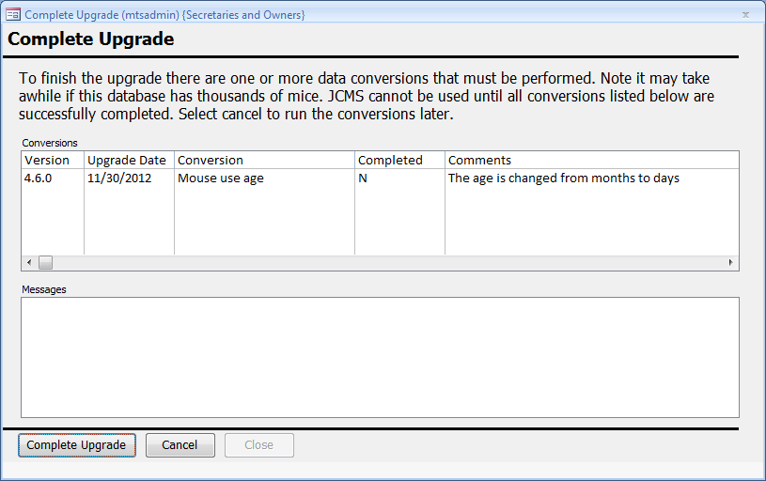

# Functional improvements

Below is a description of the new functionality that went into this release. For a complete description please see the user guide.

## New features

#### Mouse Use Calendar

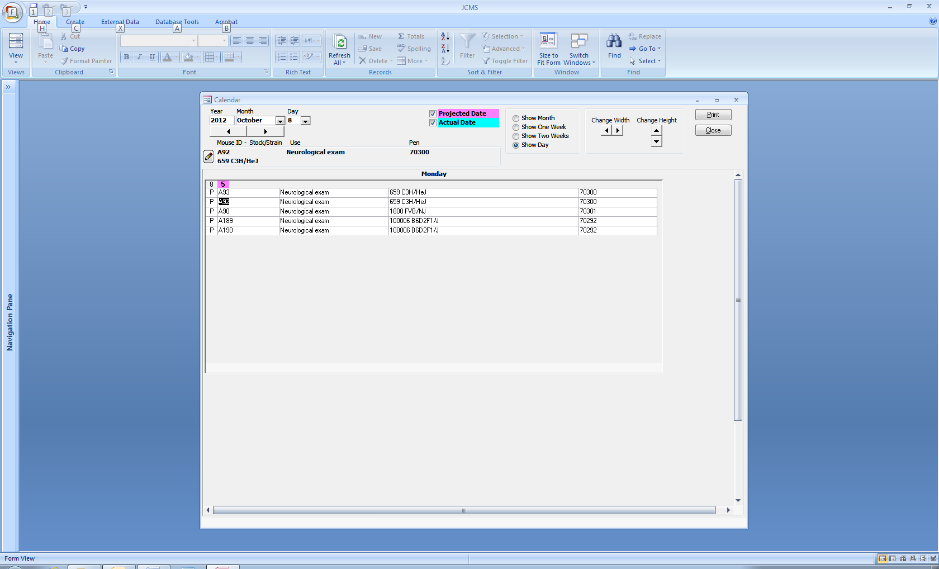

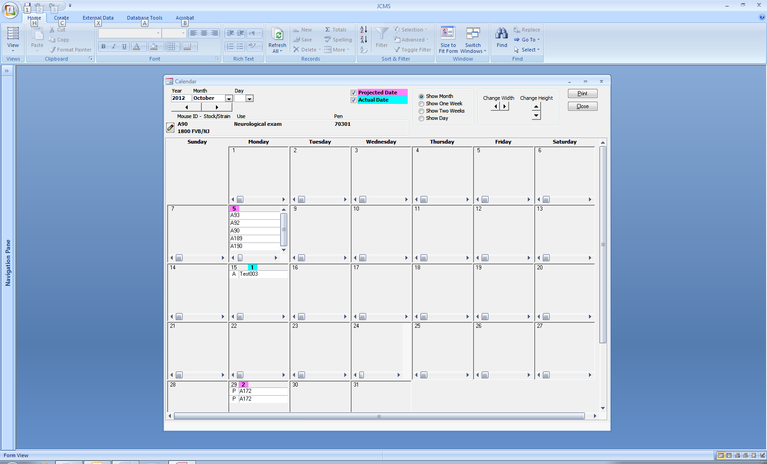The calendar provides a display of selected mouse uses by projected and/or actual dates. Four formats are available, day (above), month (on left), one week, or two weeks. The width and height of the space for each day is customizable. The mouse uses shown may be filtered by use term (ex: neurological exam), use status (done or not done), owner, and strain/stock #. Dynamically change if the use(s) are shown for projected and/or actual date by using the pink and cyan check boxes on the form. Each row is labeled with “P” for projected date or “A” for actual date. Click on a specific row in the calendar to show more information about the selected mouse at the top left of the form just below the date selection. Click the edit button (pencil icon) to open the Edit Mouse Use form for that mouse. Double click on a specific calendar row to open the new mouse use details form shown below.

#### Mouse Use Details

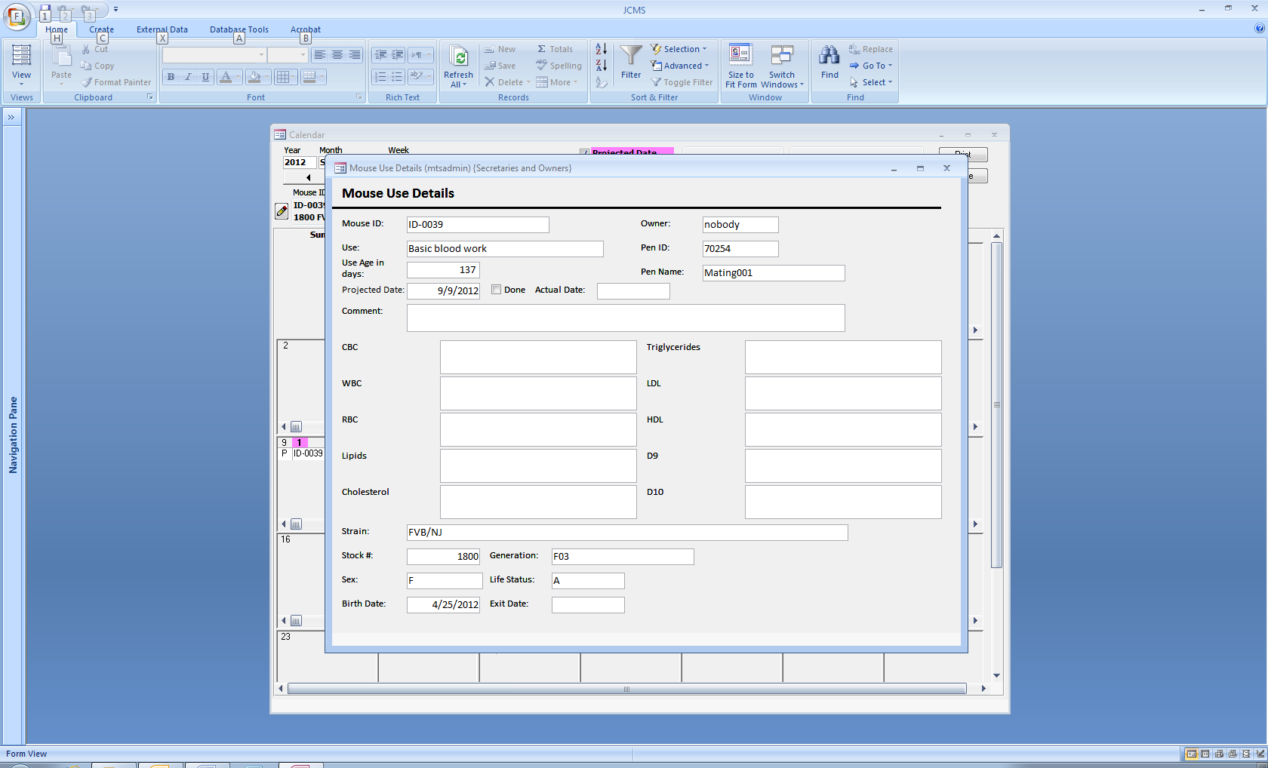

#### Plug Dates and DPC Mouse Uses

Mouse uses that should occur at a certain number of days post conception (DPC) may be added to the dam when the plug date is added using the Add Plug Date form. There is a new section at the bottom of the Add plug date form for specifying the use term and DPC. The projected date is calculated based on the plug date. Several mouse uses may be added all at once.

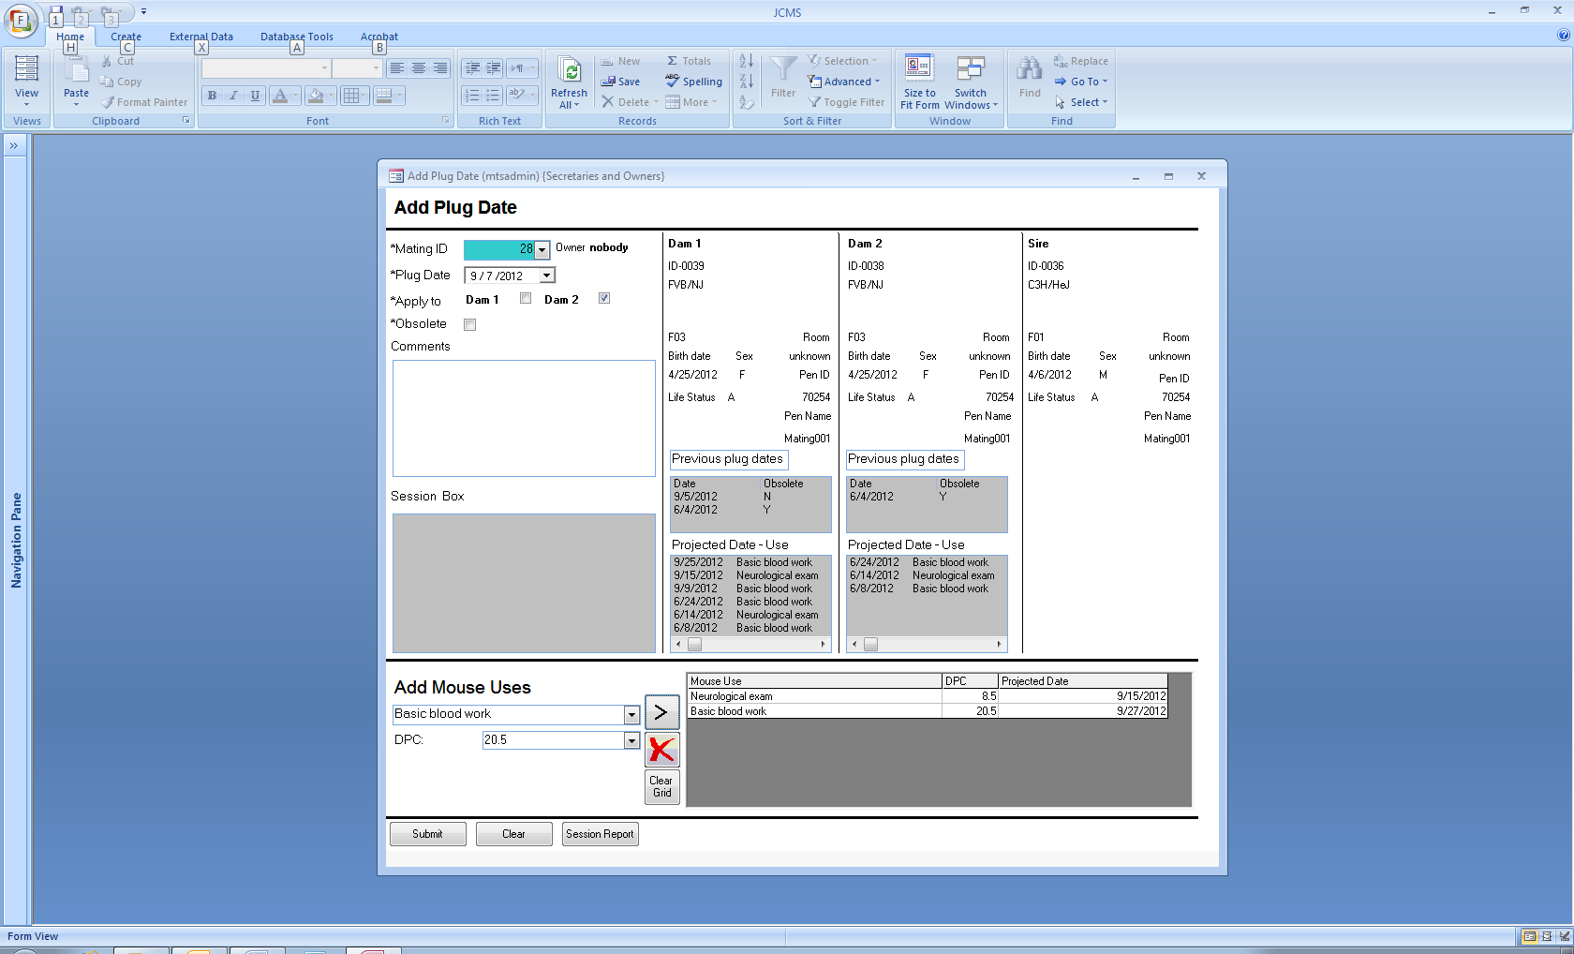

The Mouse Use form may also be used to enter a use that is dependent on a plug date. The projected date is automatically calculated based on the selected number of days after the plug date. The use age is then set to be the mouse’s age on the projected date.

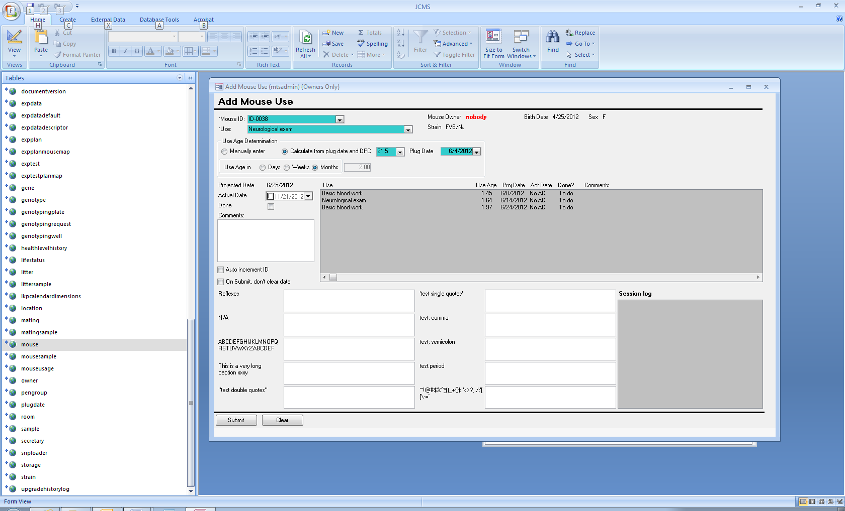

#### Bulk Method for Setting Plug Dates to be Obsolete

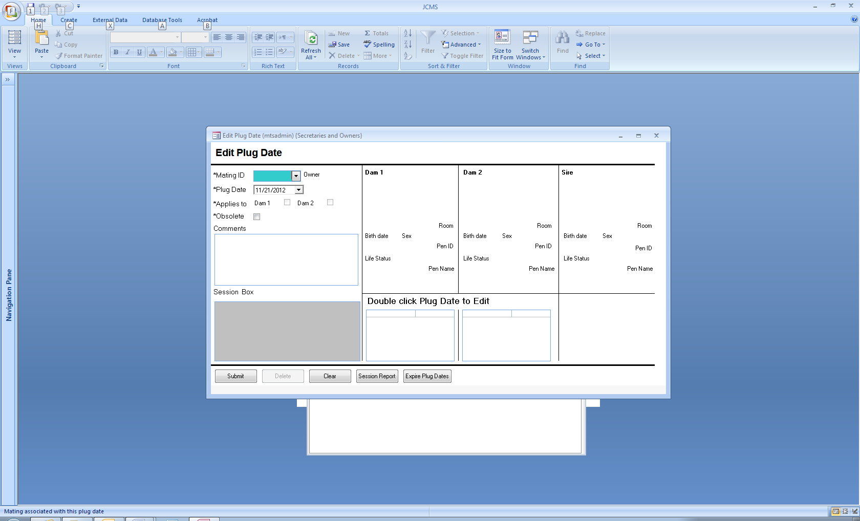The Edit Plug Date form has a button called Expire Plug Dates. Use it to set all plug dates a certain number of days prior to today to be obsolete. The number of days is determined by the setup variable JCMS_GESTATION_PERIOD. The default is 21 days.

#### Mouse Use Captions and Active Status

The ten data fields associated with a mouse use may use a caption or be called by default D1, D2, D3, … D10. The administrator sets the captions using the Add or Delete Mouse Use Types form, which is opened from the Administrator Buttons form (black arrow below). All fields except the mouse use term may be edited. A caption may not be blank, it is suggested to use N/A as the caption for unused fields or leave them at the default.

A mouse use may be designated as not active (blue arrow below). These terms will not be available as a choice when adding new mouse uses but are still available for queries, reports, and editing older data.

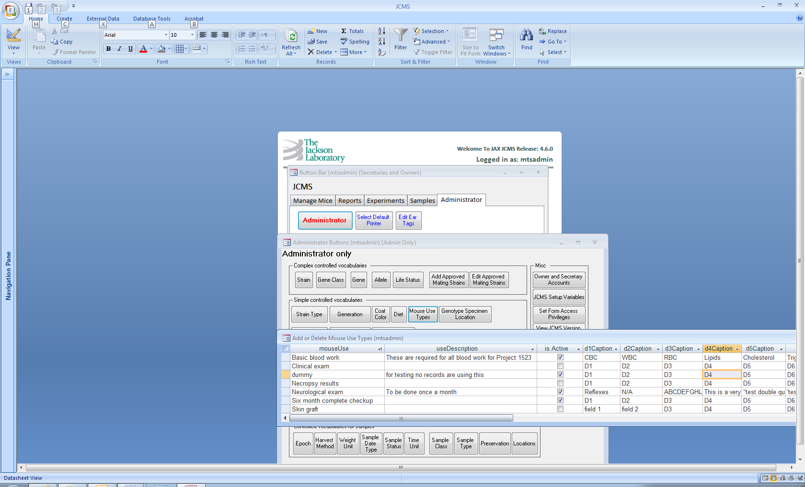

#### Mouse Use Age Now Calculated Using Days

Previously, JCMS used months to determine the mouse use age. This release has changed the use age to be stored in days. It may be displayed on the form in days, weeks, or months depending on the radio button selected.

The calculation of the number of days in a month has been changed to use 30.4375 days in a month to be consistent with the other places in JCMS where age is displayed. Previously, use age was calculated using 30 days in a month.

This means that user’s data has been modified slightly when it is converted by this upgrade.

* If the data included a projected date, then the use age was calculated in days by determining the number of days between the projected date and the mouse’s birth date in order to obtain the exact use age in days.
* If the data had no projected date, then the age in months was multiplied by 30.4375 days and rounded to determine the age in days. This occasionally creates a slight discrepancy, for example: 3 months is now 91 days (not 90). When 91 days is displayed in months, it is shown as 2.99 on the form instead of 3.00.

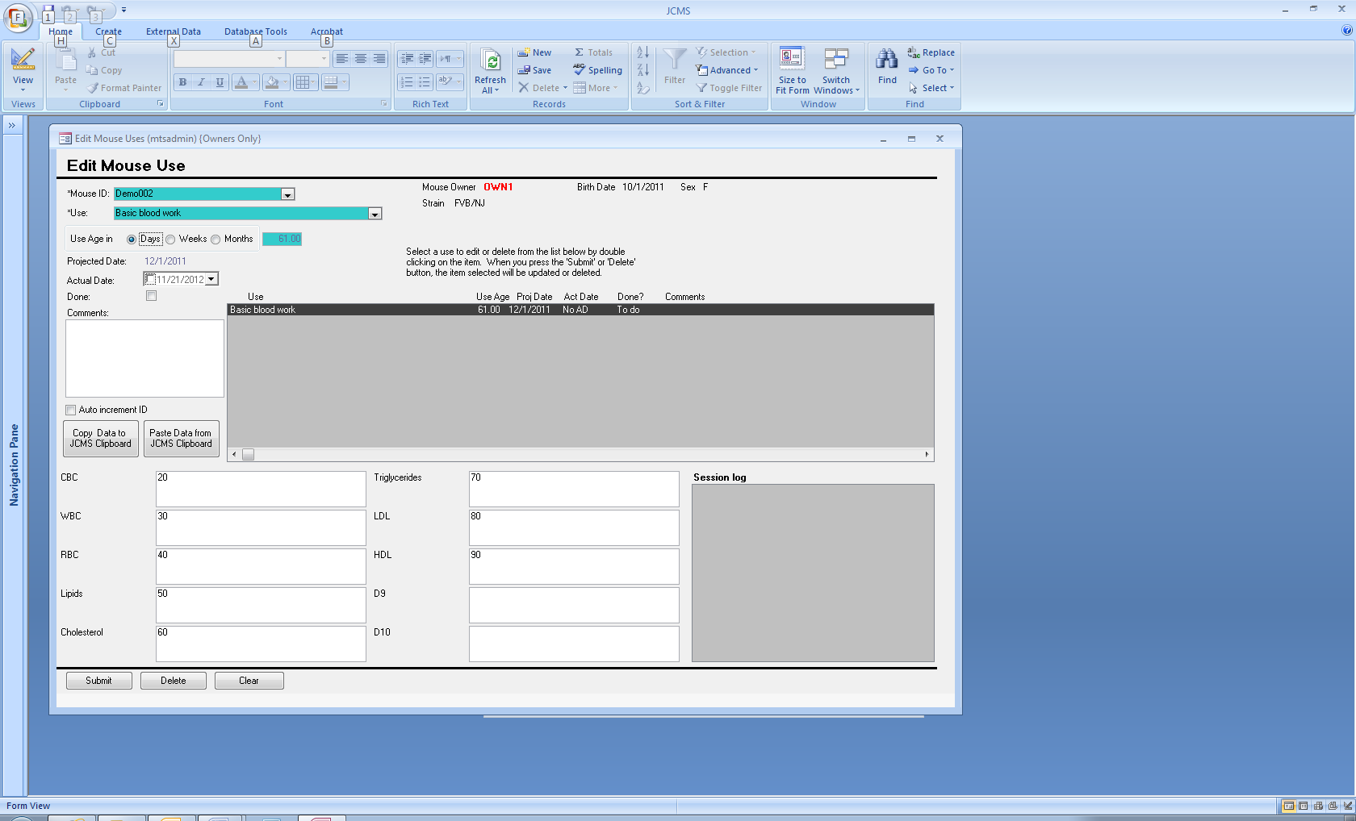

**Release No: 4.5.0**

June 18, 2012

## Functional improvements

Below is a description of the new functionality that went into this release. For a complete description please see the user guide.

### New features

#### Breeding Performance Report

There are six different formats for the breeding performance report. The information in the report is shown for selected strains, owners, and time frame. Matings are selected for the report based on having a mating date within the time frame.

* The full report includes details on all matings and litters, including the mating ID; mating and retired dates; dam1, dam2, and sire; litter ID; birth, wean, and tag dates; # born, # females, and # males. Included are the total number of matings, litters, and matings with no litters for each owner and strain.
* The summary report provides the same totals as the full report but eliminates the details for each litter.
* The tabular spreadsheet provides the data in a format that can be easily exported to Excel. One row is provided for each litter or, if the mating has no litters, one row for the mating.
* The litter detail pivot table provides a dynamic table showing the # born, # females, and # males for each mating and litter broken out by year/quarter/month.
* The litter summary pivot chart provides a dynamic graph showing the # litters, # born, # females, and # males by year/quarter/month.
* The mating count pivot chart shows the number of matings started by year/quarter/month/week.

The pivot tables and charts may be switched from one format to the other. The chart format may be changed; a 3-D column chart is suggested when showing multiple strains. The rows and columns may be expanded or collapsed. If more than one owner or strain was originally selected, these may be filtered to show only one. Each pivot table or chart is based on a temporary query of the database used to retrieve the requested information. If the original format of the chart or table is lost, simply return to the Breeding Performance Report form and request it again.

## Usability changes

### Pen selection

The pen selection area used for adding, selecting, and editing pens (cages) has been re-done. Visually it will continue to look the same as JCMS 4.4.0.

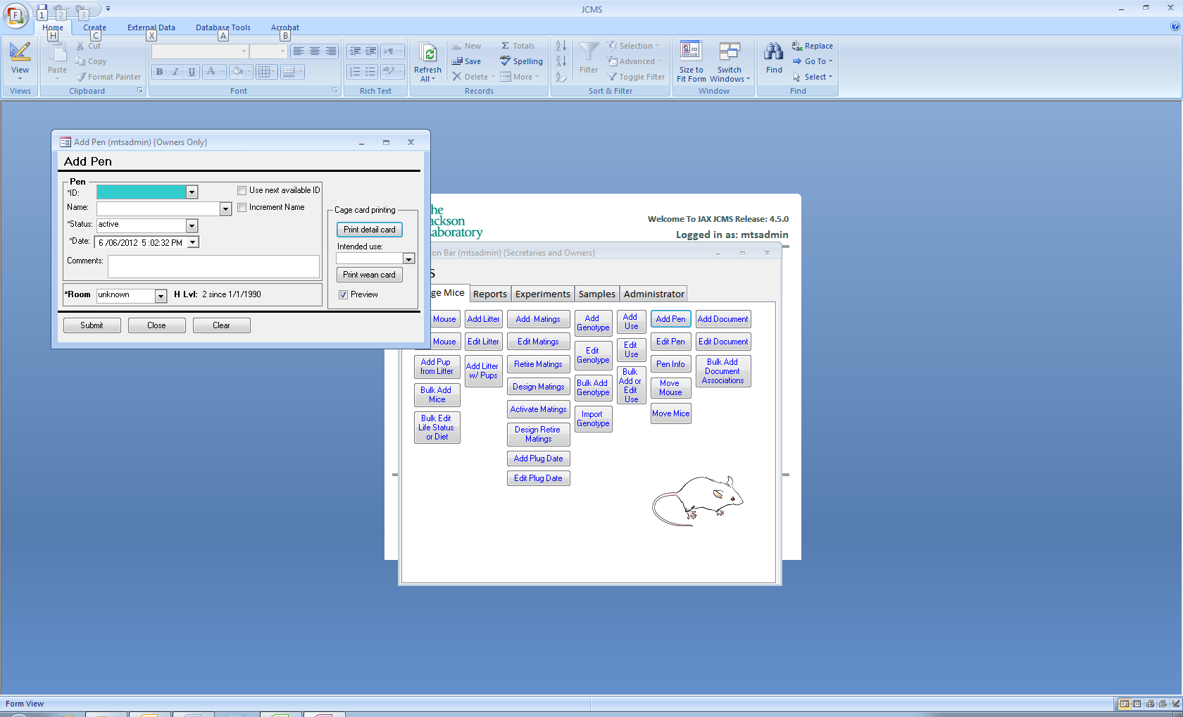

* The performance of forms containing a pen selection area has been improved.
* The pen name field will not be colored cyan (see above) in circumstances where entering a name does NOT choose a pen, but instead provides a name for adding or incrementing.
* Entering pen IDs or names by typing has been improved and now includes an auto-complete as you type feature. Backspacing to remove characters no longer rings a bell.

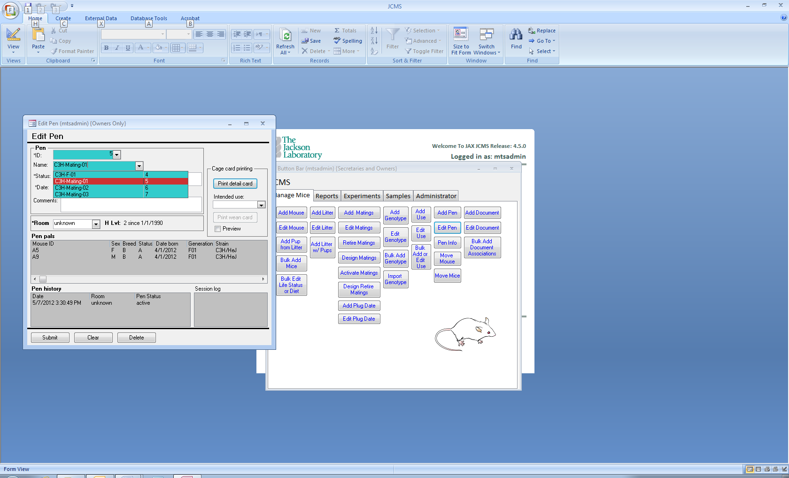

* Pen names will show the associated pen ID in the drop-down list (see example above).
* When the setup variable JCMS_SORT_BY_PEN_NAME is false, the pen name list will sort instead by pen ID descending as shown below. A quick way to change this setup variable is to use the administrator’s Manage Pen Configuration form.

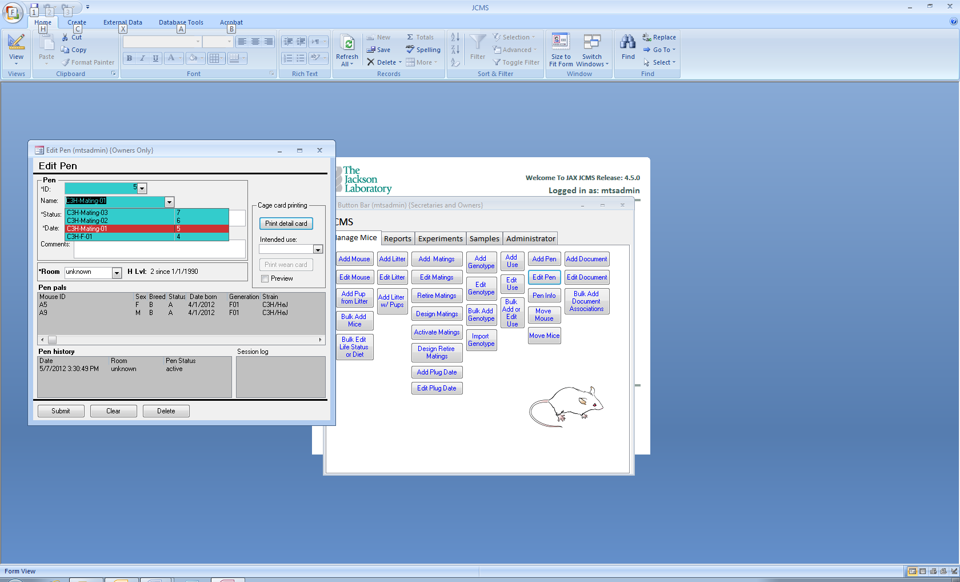

* The bug that caused some forms to select the incorrect pen ID when typing a pen name has been fixed.

### Bulk Adding Mice to Experimental Plans and Tests

This form has been altered to improve usability by showing more test choices. Note it is opened from the Query Mouse form by using the Add Mice to Experiment button (see the example below).

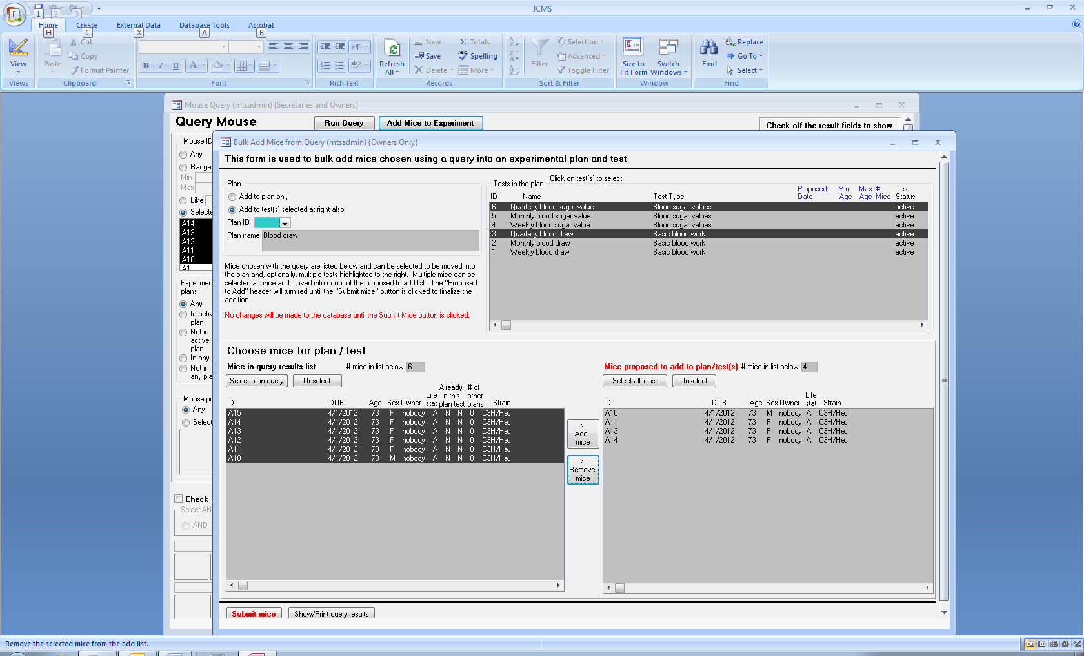

## Defect fixes

### Experiment Query form

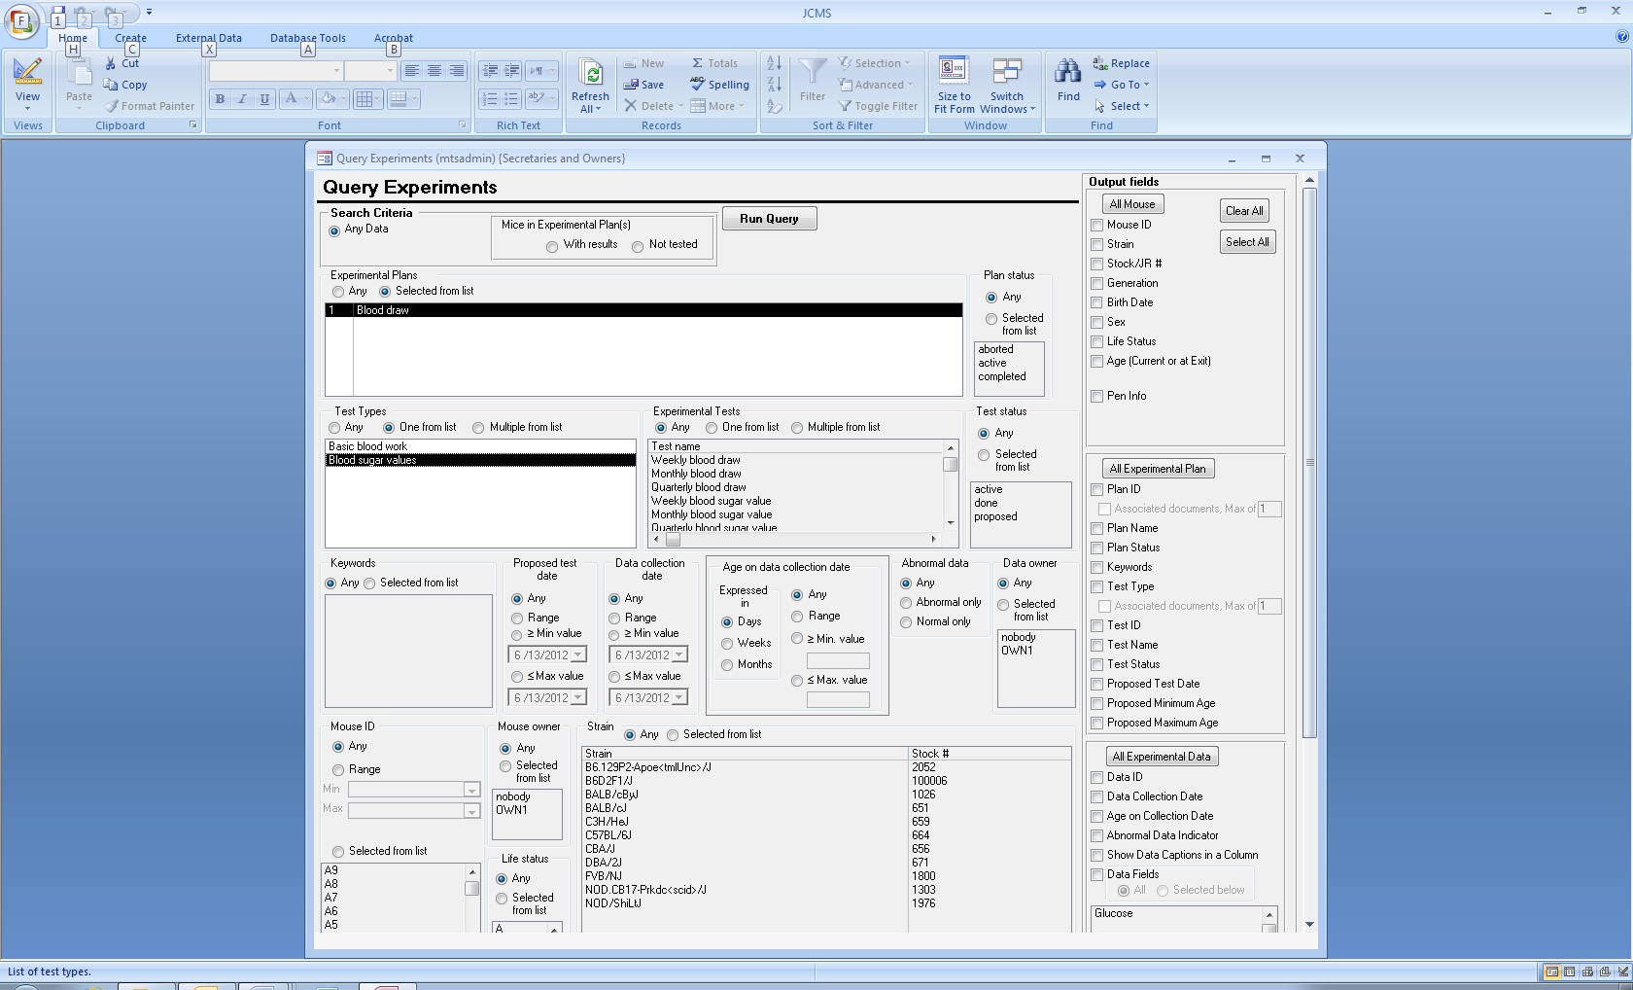A user can have experimental plans and also have some experimental data that is not associated with any experimental plan.

In this situation, when the Experiment Query criteria was set to “Any Data” and other criteria indicated a specific experimental plan and/or experimental test, data not associated with any experimental plan or test was erroneously included in the results.

For example, the criteria shown to the left includes a specific experimental plan and a specific test type. Now only data associated with the selected experimental plan is returned. To see the data that is not associated with any experimental plan, set the experimental plan choice to “Any”

## Permission problem for an owner

An owner who is also a secretary for a different owner was unable to edit the other owner’s litters. This permission issue has been corrected.

# Upgrade completion

If upgrading from a version of JCMS prior to 4.4.0, the “Complete Upgrade” button will appear on the main menu (see the release notes for JCMS 4.4.0 below). We recommend running this process at your earliest convenience. Also, please note that this one time process will have to be run once prior to using JCMS Web.

**Release No: JCMS 4.4.0**

December 28, 2011

## To Complete Upgrading to JCMS 4.4.0

Users of a prior version of JCMS must run the JCMS Upgrader and then, after starting JCMS version 4.4.0, run a one-time process to complete the necessary changes.

A *Complete Upgrade* button is displayed on the main menu. After successful completion of the process, the button will no longer be present. If you have many mice in the database, this process may take awhile. In multi-user installations the process does not need to be run by each user. No changes will be made to your data. No harm will be done if this process is run more than one time.

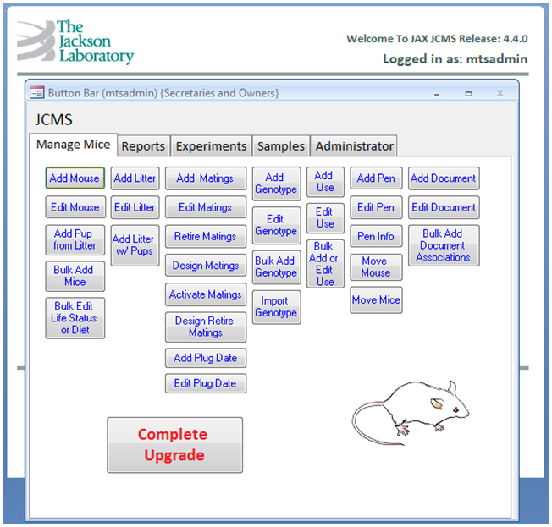

Click here to finish the upgrade to JCMS 4.4.0.

## Functional improvements

Below is a description of the new functionality that went into this release. For a complete description please see the user guide.

### New features

### Query forms

Query Matings and Query Samples may now be used to extract documents associated with matings, litters, and samples.

Query Matings has a new option to list litters sorted by the most recent birth date.

### Active Strains

The Administrator can designate a strain as active or not. The default for existing strains is active.

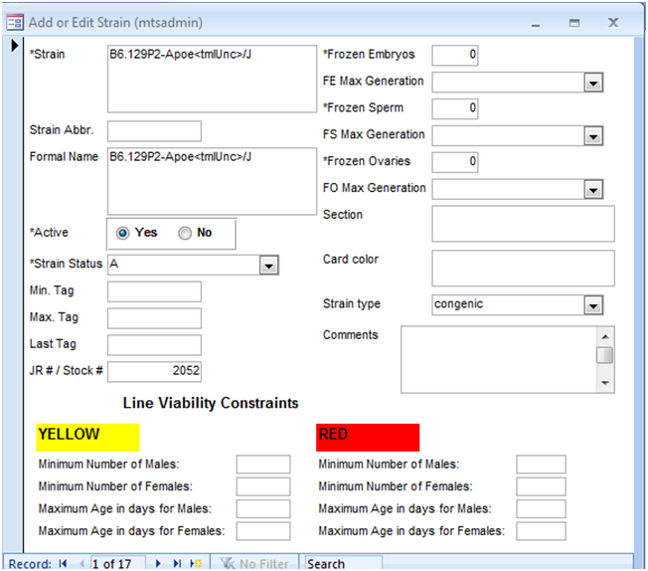

Designate a strain active or not.

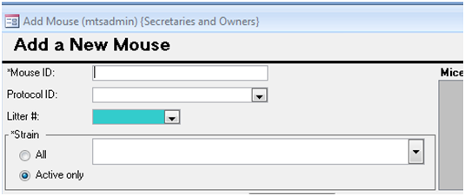

Inactive strains are not available as a choice when *Active only* is selected. Choose *All* to see every possible strain in the list.

Using approved strains overrides the inactive status choice and only approved strains (even if inactive) are available.

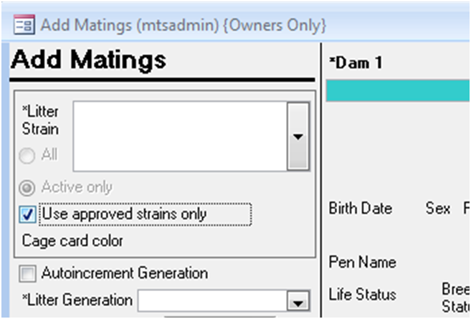

*All* or *Active only* are not choices when *Use approved strains only* is selected.

## Usability changes and defect fixes

A number of small changes were made to version 4.4.0 that had to do with making the application more usable or fixing defects. The following list is some of the more salient changes.

* On the query mouse and query experiments forms, the error message about a missing document path has been changed to a warning.
* Some instances where an hourglass cursor was incorrectly displayed for too long have been removed.

**Release No: JCMS 4.3.0**

October 25th, 2011

## Functional Improvements

Below is a synopsis of the new functionality in release 4.3.0. For a complete description please see the user guide.

### Associating documents

This release of JCMS focuses on attaching documents to objects in the colony. With this release you will be able to upload files and associate them with mice, matings, litters, mouse uses, samples, experimental test types, experimental plans, and specific genotype data.

New Button

Once attached you can extract the data from the database by using the query forms and open the documents by virtue of the hyperlink that is provided in the output.

### Sample sources

The user has greater flexibility in identifying sources of samples. In the past, there was a constraint that the sources of a sample had to be from the same strain. Though this was logical for most cases there were other situations where it was too constricting. In this release the user can specify multiple sources for a sample irrespective of whether they are of the same strain.

As before the *strain of the sample* is specified in **Source of Sample** portion of the screen.